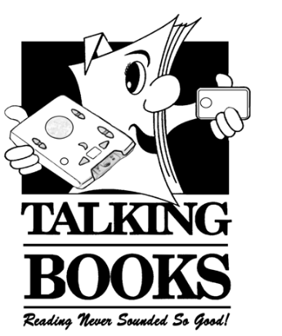
Touch and Listen:
The Newsletter of the Florida Bureau of Braille and Talking Book Library
Summer 2017

How to Reach Us When You Can’t Reach Us

Since we serve thousands of patrons, odds are good if you regularly call the Braille and Talking Book Library with questions and requests, you will reach our voicemail rather than a live person. Here are some tips to make the best use of our voicemail:

- Don’t hang up! Leave us a message.
- In the message, be sure to leave us your name and provide your phone number so we can contact you! Also, remember to spell out your last name. If you are calling on behalf of someone else, please leave the name of the patron.
- Let us know what you need. If you have requests, feel free to leave those in your message. If you have a question, ask it in the message, giving as much information as you can so we can have an answer for you when we call you back.
- Please let us know what works for you, tell us if you want a return call or just simply to add books to your list without a call back. We want you to be happy!
- For patrons with email access, you can send us a message at opac_librarian@dbs.fldoe.org, but the same tips apply! Include your full name along with the reason you’re writing so we’ll know who you are and what you need.

Support For All Your Needs

Hadley Offers Free Adult Courses

Hadley Institute's Adult Continuing Education (ACE) Program offers courses for the blind or visually impaired. Anyone age 14 or older, blind or meets vision eligibility requirements is eligible to enroll. Materials and instruction in the ACE Program are free. Hadley offers year-round enrollment with courses in audio, braille, and large print. Some advantages of the program:

- Learn to read and write braille
- Adjust to life after vision loss
- Enhance independent living skills
- Improve employability and business skills
- Discover the joys of lifelong learning

For more information, visit their website at www.hadley.edu or contact them via the following:

- 847-446-8111 (Main)
- 800-323-4238 (Toll Free)
- 847-441-8111 (TTY hearing impaired callers)
- 847-446-9820 (Fax)
- info@hadley.edu

Accessibility Phone Support from Microsoft and Apple

Microsoft’s Disability Answer Desk (DAD) specializes in assisting customers with disabilities and provides support using accessibility settings in Microsoft products. Help is available for screen magnifiers, speech recognition software, Microsoft-compatible devices and accessibility features.

The DAD can be contacted at 1-800-936-5900 from Monday – Friday from 9 – 1 a.m. Eastern Standard Time (EST), and weekends from 10 a.m. – 9 p.m. EST. For more information, including a 24/7 chat link, visit microsoft.com/enable.

Apple Accessibility also offers telephone support for customers with visual, hearing, motor or learning impairments and is available 24/7. For more information, call 877-204-3930 or visit apple.com/support/accessibility.

Comcast XFINITY Accessibility Support Center

XFINITY customers who rely on accessibility services - including video description and voice guidance - now have direct access to a specially trained support team via Comcast's Accessibility Support Center for Customers with Disabilities. The Support Center assists with:

- Enabling video description on your TV box through XFINITY X1.
- Using voice guidance, the talking guide feature on X1.
- Requesting braille bills, channel lineups, or XFINITY User Guides.
- Requesting a large button XFINITY remote control.
- Obtaining operator services/directory assistance exemptions.

You can reach the Support Center by calling 855-270-0379 or emailing accessibility@comcast.com between the hours of 8 a.m. and midnight EST, seven days a week. For more information or online support, visit xfinity.com/accessibilitysupport.

Fresh from the Recording Studio:

Multiple Book Cartridges

Multiple Book Cartridges (MBCs) are now available. As their names suggests, each MBC features multiple titles from popular authors and series. This is a great, new way for patrons to receive several books in a collection – all at once!

MBC: Alex Cross 1-5 (FDB03832) Along Came a Spider; Kiss the Girls; Jack and Jill; Cat and Mouse; Pop Goes the Weasel (Author: James Patterson)

MBC: Alex Cross 6-10 (FDB03833) Roses are Red; Violets are Blue; Four Blind Mice; The Big Bad Wolf; London Bridges (Author: James Patterson)

MBC: Kinsey Millhone 1-5 (FDB03864) A is for Alibi; B is for Burglar; C is for Corpse; D is for Deadbeat; E is for Evidence (Author: Sue Grafton)

MBC: Kinsey Millhone 6-10 (FDB03865) F is for Fugitive; G is for Gumshoe; H is for Homicide; I is for Innocent; J is for Judgment (Author: Sue Grafton)

MBC: Cedar Cove 1-12 (FDB03878) 16 Lighthouse Road; 204 Rosewood Lane; 311 Pelican Court; 44 Cranberry Point; 50 Harbor Street; 6 Rainier Drive; 74 Seaside Avenue; 8 Sandpiper Way; 92 Pacific Boulevard; 1022 Evergreen Place; 1105 Yakima Street; 1225 Christmas Tree Lane (Author: Debbie Macomber)

MBC: Harry Potter series (FDB03863) Harry Potter and the Sorcerer's Stone; Harry Potter and the Chamber of Secrets; Harry Potter and the Prisoner of Azkaban; Harry Potter and the Goblet of Fire; Harry Potter and the Order of the Phoenix, Harry Potter and the Half-Blood Prince; Harry Potter and the Deathly Hallows (Author: J.K. Rowling)

MBC: Mortal Instruments series (FDB03857) City of Bones; City of Ashes; City of Glass; City of Fallen Angels; City of Lost Souls; City of Heavenly Fire (Author: Cassandra Clare)

MBC: Jack Ryan 1-5 (FDB03852) The Hunt for Red October; Patriot Games; The Cardinal of the Kremlin; Clear and Present Danger; The Sum of All Fears (Author: Tom Clancy)

MBC: Stephanie Plum 1-10 (FDB03876) One for the Money; Two for the Dough; Three to Get Deadly; Four to Score; High Five; Hot Six; Seven Up; Hard Eight; To the Nines; Ten Big Ones (Author: Janet Evanovich)

MBC: Sackett 1-5 (FDB03839) Sackett's Land; To the Far Blue Mountains; The Warrior's Path; Jubal Sackett; Ride the River (Louis L’Amour)

New FDBs

Nerd Camp (FDB03817) by Elissa Brent Weissman. 4 hrs. 55 mins. Narrator: Derek Beauchamp. For 10-year-old Gabe, the Summer Center for Gifted Enrichment is all that he dreamed it would be. But he must work hard to write about the fun in letters to Zack, his cool future stepbrother, without revealing that it is a camp for "nerds."

Bridger's Run (FDB03793) by Jon Wilson. 8 hrs. 15 mins. Narrator: Jess Baker. Tom Bridger comes to Florida in 1885 to find his long-lost uncle and a hidden treasure. Heading west across Florida's wild frontier, he faces several brushes with death, including gator-filled swamps and a footrace with a stagecoach, culminating in a boxing match between Bridger and Bongo Jones, the Key West Slasher.

The Savants (FDB03820) by Patrick Kendrick. 6 hrs 20 mins. Narrator: Dave Archard. A renowned behavioral scientist conducts an unprecedented experiment with savants teaming up on a project. But soon a catastrophic event challenges the group even further; they must work together and using their incredible skills to save the world.

Totch: A Life in the Everglades (FDB03776) by Loren G. Brown. 8 hrs. 55 mins. Narrator: Abbey Jansen. Colorful recollections of an Everglades old-timer, Loren "Totch" Brown. A hardscrabble life – particularly when it involved farming or fishing on the shell islands. But it was also a wonderful life; Totch always had a great time, whether hiring out to Hollywood and getting to know Peter Falk and Burl Ives, or running a charter and watching Richard Nixon fall from the boat.

The Case of the Sulky Girl (FDB03831) by Erle Stanley Gardner. 9 hrs 35 mins. Narrator: Margaret Tedrick. Unable to marry due to a stipulation in her late father's will - which states that she will lose his millions if she does wed - headstrong Frances hires Perry Mason to get around the clause, and soon he ends up solving a family murder.

The Price of Justice (FDB03815) by Marti Green. 7 hrs. 9 mins. Narrator: Pam Masters. Winston Melton is accused of the rape and murder of an ex-girlfriend. Years after his conviction, another death-row inmate comes forward with an eleventh-hour confession, casting Win's conviction in a new light. But with the ink drying on his death sentence, time is running short.

Planted With Hope (FDB03826) by Tricia Goyer & Sherry Gore. 10 hrs. 30 mins. Narrator: Sue Christenson. Hope Miller finds her plans for the plot of land she is given behind her sister's pie shop changing after teacher Jonas Sutter asks if his students can use it to make a community garden.

Happening At Your Library

“Please DO touch:” Art for the visually impaired

“A Touch of Art” opened in the Peabody Auditorium in Daytona Beach March 7. Compiled over a two-year period by 15 local artists with the Experimental Mixed Media Artists (EMMA), the show is specifically intended for persons with visual impairments. The 69 pieces created include highly textured 3-D art that is meant to be explored by touch. EMMA, which is associated with the Daytona Beach Art League and the City of Daytona Beach, provided the gallery and the opening night refreshments.

The idea is “to communicate what we see to those that can’t, and have a shared experience that can’t be put into words,” said Gail Bokor, instructor with the Daytona Beach Art League. “This exhibition will also give us a chance to share the visual experience and educate a part of the community about the many kinds of art there are.”

The DBS Braille and Talking Books Library became involved through one of its volunteers who has been working with the group. At their request, the Library produced the programs in braille and helped circulate the show’s flyers to contacts in the local community.

The response from the public surpassed the wildest expectations of the artists, who were present at the opening to discuss their work with attendees. More than 300 people attended, including groups of students and families from the Rehabilitation Center, the Center for the Visually Impaired clients, and the Conklin Center for the Blind. The reaction from attendees with visual impairments was enthusiastic and positive, and sighted people also enjoyed the chance to experience tactile art.

A number of people suggested that the exhibition should be shown in other cities, and the organizers are now exploring the idea of taking it on the road. Five of the sub-regional Talking Books Libraries have expressed interest in hosting the show in their communities. The Museum of Arts and Science in Daytona Beach has also shown interest. The organizers are now considering grant-writing to secure funding to underwrite expenses for transporting the pieces around the state.

Many pieces from the show are now on exhibit in the CVI, the Library and the Conklin Center, as long-term loans from the artists.

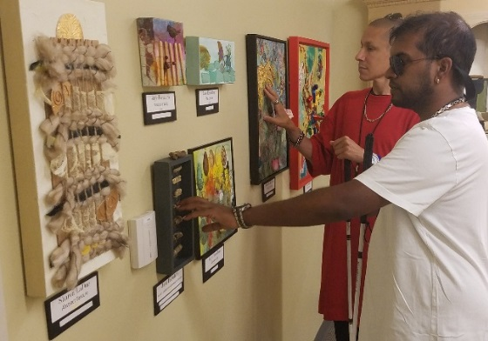

Celebrating the Library’s Stars

In April, the Braille and Talking Books Library held its 43rd Annual Volunteer Appreciation Luncheon to honor its volunteer staff of more than 100 who help in all areas of operations, including circulation, inspection, clerical, machine maintenance, production, public relations and the recording Studio to help the Library deliver services to its readers. Friends of Library Access sponsored the luncheon.

Attendees included library staff, volunteers, DBS personnel and invited guests. Friends of Library Access President Sheila Young welcomed the group, Bureau Chief Jim Woolyhand provided a library update and DBS Director Robert L. Doyle III, thanked the volunteers for their services.

Certificates were presented to volunteers in recognition of their hours of service, including three persons who have logged more than 4,000 hours and one person who has given 6,000 hours of service. One volunteer had just completed 32 years with the Library and eight others have volunteered more than 25 years.

A number of volunteers are Library patrons themselves. We are so grateful for our stars, the volunteers, who help the Library serve its readers. Many, many thanks!

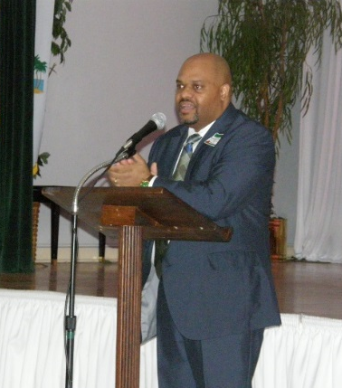  DBS Director Robert Doyle III | 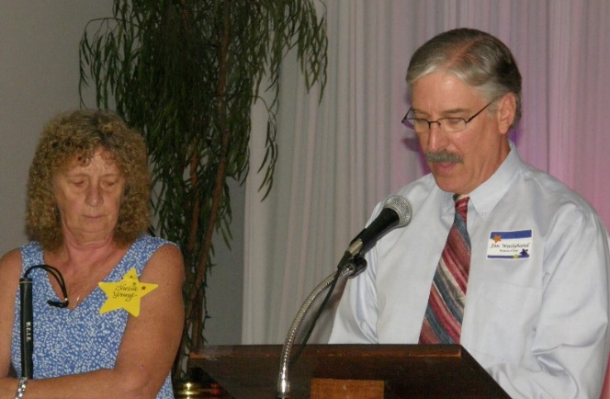  Sheila Young, President of the Friends of Library Access, Inc. with Jim Woolyhand, Library Bureau Chief

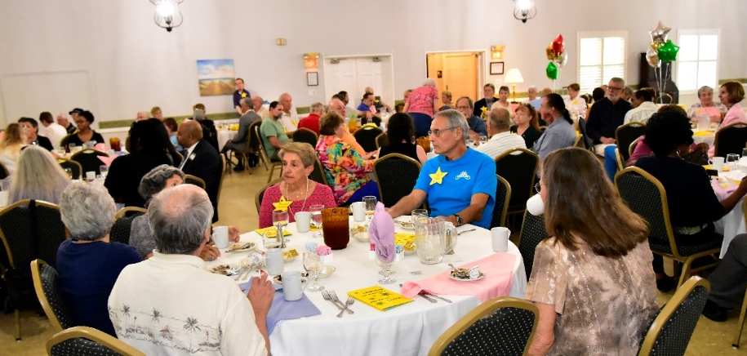
110 people attended the event to honor the volunteers who help the Library serve our patrons

Free matter for the blind and physically handicapped

Bureau of Braille and Talking Book Library Services
421 Platt St.
Daytona Beach, FL 32114

The Bureau of Braille and Talking Books Library Services is part of the
Division of Blind Services, Florida Department of Education.
Visit our websites at http://dbs.myflorida.com/ or www.fldoe.org.

The Bureau of Braille and Talking Books Library Services is part of the
Division of Blind Services, Florida Department of Education.
Visit our websites at http://dbs.myflorida.com/ or www.fldoe.org.

The Bureau of Braille and Talking Books Library Services is part of the
Division of Blind Services, Florida Department of Education.
Visit our websites at http://dbs.myflorida.com/ or www.fldoe.org.

The Bureau of Braille and Talking Books Library Services is part of the
Division of Blind Services, Florida Department of Education.
Visit our websites at http://dbs.myflorida.com/ or www.fldoe.org.

The Bureau of Braille and Talking Books Library Services is part of the
Division of Blind Services, Florida Department of Education.
Visit our websites at http://dbs.myflorida.com/ or www.fldoe.org.
Important Newsletter Update: Touch and Listen is now published bi-annually in large print, in the spring and fall. It is published quarterly in audio in Spanish and English, in braille, Word documents, and in a text-only version for adaptive technology screen reading programs. Go to http://dbs.myflorida.com/Library/index.html and click “Touch and Listen Newsletter.”

