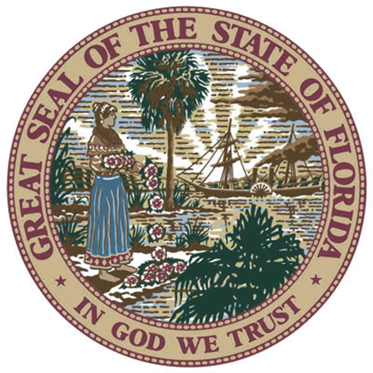
Florida
Rehabilitation Council
for the
Blind

Annual Report
2014
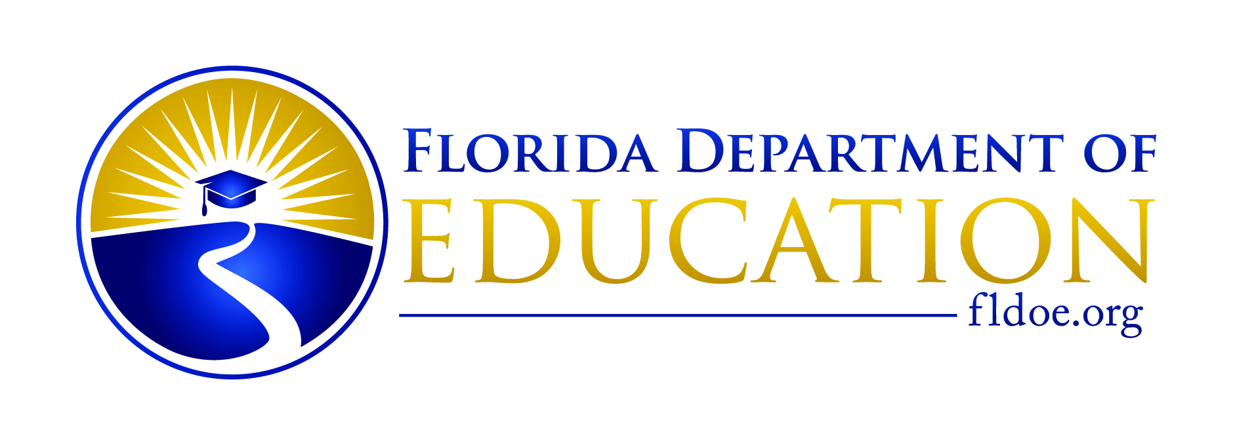
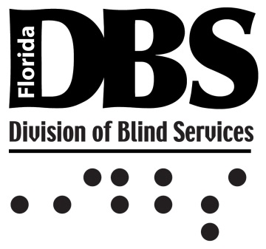

STATE OF FLORIDA

division of blind services

FLORIDA REHABILITATION COUNCIL FOR THE BLIND
ANNUAL REPORT

Federal Fiscal Year 2014

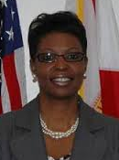
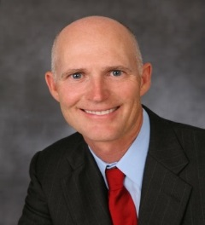

Rick Scott
Governor
State of Florida

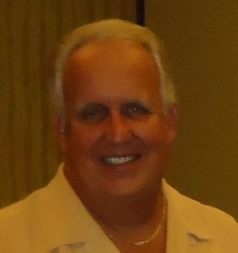
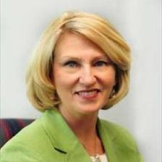
Pamela Stewart
Commissioner of Education
Florida Department of Education

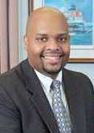

Robert L. Doyle, III
Director
Division of Blind Services

Antionette Williams, Ph.D.
Deputy Director
Division of Blind Services

Bruce Miles
Chairman
Florida Rehabilitation Council for the Blind

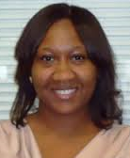
Alise Fields
Government Operations Consultant
Florida Rehabilitation Council for the Blind

DIVISION OF BLIND SERVICES
district and Bureau of Business Enterprise regional offices

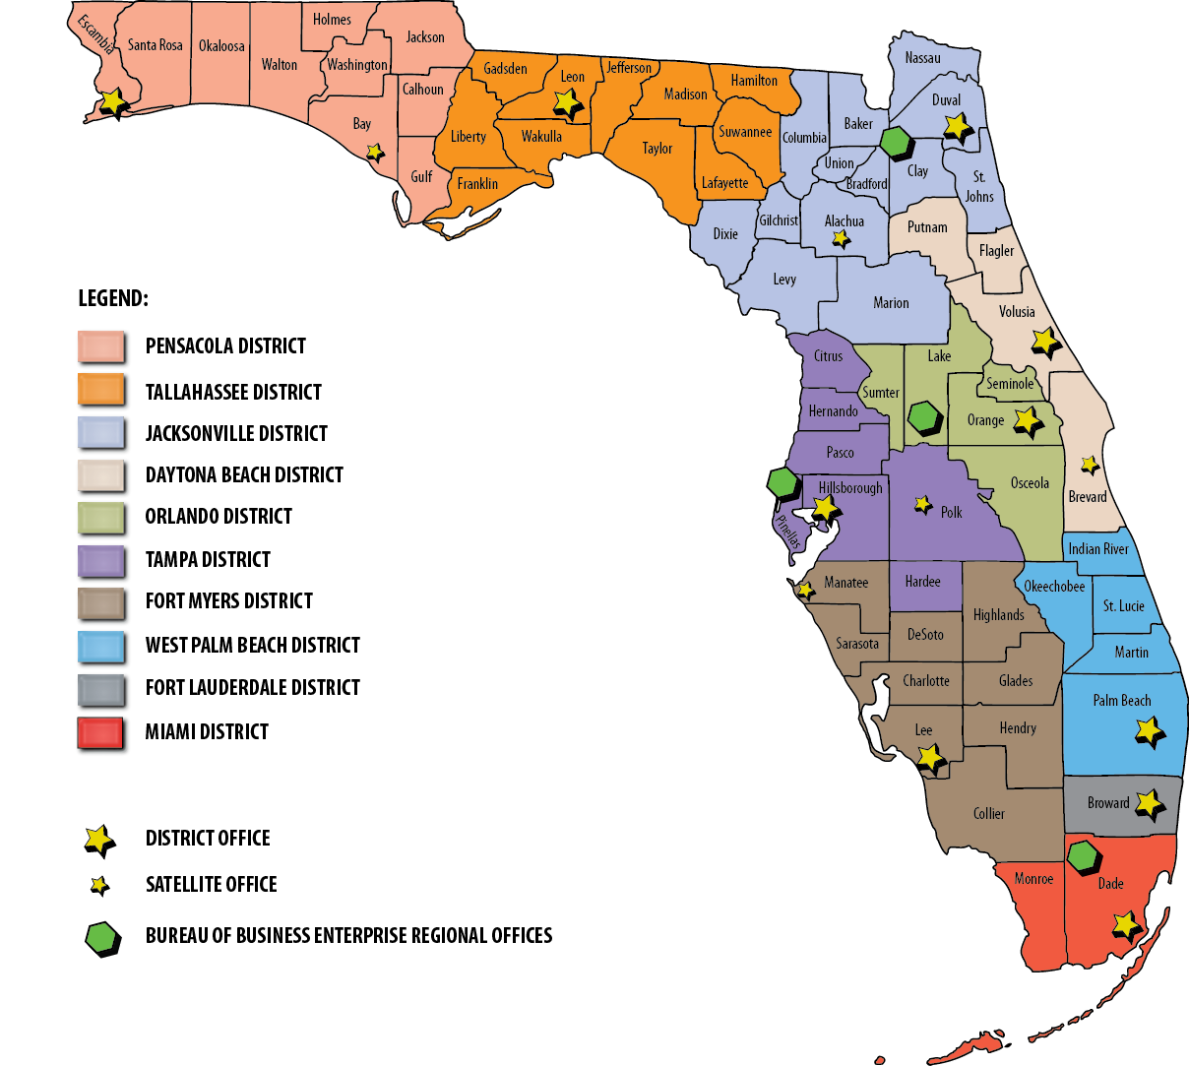

Florida Division of Blind Services

MISSION STATEMENT

To ensure blind and visually-impaired Floridians have the tools, support and opportunity to achieve success

Florida Rehabilitation Council for the Blind

MISSION STATEMENT

“The Florida Rehabilitation Council for the Blind reviews, analyzes & advises on the policy decisions and evaluates the effectiveness of the Florida Division of Blind Services to ensure meaningful access to and use of vocational rehabilitation and independent living programs for Floridians who are blind or visually impaired.”

VISION STATEMENT

“The Florida Rehabilitation Council for the Blind functions to create a positive impact on the fairness, efficiency, and accessibility of services through the evaluation of consumer feedback and the Florida Division of Blind Services’ performance.”

State of Florida Rehabilitation Council

for the Blind

Fairness, efficiency, accessibility, integrity,
commitment, EXCELLENCE, ADVOCACY, diversity, leadership, partnership, teamwork, culture,
communication

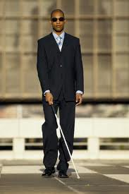
Enclosed is a copy of the Florida Rehabilitation Council for the Blind’s (FRCB) Federal Fiscal Year 2014 Annual Report to the Commissioner of the Rehabilitation Services Agency and Governor Rick Scott.

Please contact Alise Fields, Government Operations Consultant to the FRCB, if you have questions or comments regarding its contents. Alise can be reached at the address and telephone number below, or via e-mail at Alise.Fields@dbs.fldoe.org.
Alise Fields
Florida Division of Blind Services
325 W. Gaines Street, Room 1114,
Tallahassee, FL 32399
Phone (850) 245-0392

Thank you for your interest in and support of programs that provide and promote the use of vocational rehabilitation and independent living programs for Floridians who are blind or visually impaired.

This report is available in alternate formats by contacting the Florida Division of Blind Services at (850) 245-0300 or toll free at (800) 342-1828.

table of contents

Transmittal Letter 9
FLORIDA REHABILITATION COUNCIL FOR THE BLIND COUNCIL MEMBERS… 10
MESSAGE FROM CHAIRPERSON 14
MESSAGE FROM dIRECTOR 16
CHAIR REPORT 17
FUNCTIONS AND ACCOMPLISHMENTS OF THE FRCB 18
FLORIDA division OF BLIND SEVICES GOALS AND OBJECTIVES 20
FRCB MEETINGS AND PUBLIC FORUMS 22
FRCB QUARTERLY MEETING AGENDA ITEMS 23
DISTRICT accomplishments REPORTS 24
EMPLOYER RECOGNITION 26
2014 FEDERAL FISCAL YEAR FRCB EXPENSES 27
CUSTOMER SATISFACTION SURVEY FINAL RESULTS 28
FDBS PERFORMANCE AND EMPLOYMENT OUTCOMES 30
FRCB AD HOC COMMITTEES 31
FRCB BIOGRAPHIES 33

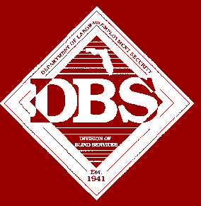

Florida Rehabilitation Council for the Blind

November 20, 2014

U. S. Department of Education, OSERS
Rehabilitation Services Administration, SMPID
Attn: Mary Williams
550 12th Street SW, Room 5017
Washington, DC 20202-2800

Dear Ms. Williams:

The Florida Rehabilitation Council of the Blind respectively submits its 2014 annual report as required by Section 105(C)(4) of the 1992 Amendment to the Rehabilitation Act. In accordance with 34 CFR 361.17, a copy of this report has been submitted to the Florida Governor’s Office.

This report presents our activities and recommendations for the 2013/2014 federal fiscal year to the Florida Division of Blind Services.

As the chair of the council, I would like to offer my appreciation and gratitude to the Division of Blind Services for its excellent support, and the council members for their diligence and contributions in serving Floridian’s with visual impairments.

If you have questions regarding this submission, please contact Alise Fields, assistant to the council at 850/245-0392.

Sincerely,

Bruce Miles, Chair
Florida Rehabilitation Council for the Blind

BM/af

cc: Governor Scott
Christyne Cavataio
2013-2014 MEMBERS
FLORIDA REHABILITATION COUNCIL FOR THE BLIND

Sheryl Brown
1106 W. Platt Street
Tampa, FL 33606
(O) (813) 251-2407
sheryl.brown@tampalighthouse.org

Representing: Business and Industry
Term Expires: 2015

Robert L. Doyle, III, Director
FDBS Rm 1114, Turlington Bldg.
325 W. Gaines St.
Tallahassee, FL 32399
(O) 850/245-0300
Robert.doyle@dbs.fldoe.org

State Director Ex-Officio

Term Expires: N/A

Paul Edwards
20330 N.E. 20th Court
Miami, FL 33179
(H) (305) 692-9206
Edwards.paul955@gmail.com

Representing: Advocacy- FL Council of the Blind
Term Expires: 2014

Jesus Garcia
5955 West 16th Lane
Hialeah, FL 33012
(O) (800) 698-8457 ext 435
jesusg@logisticare.com

Representing: Former Clients
Term Expires: 2016

Leanne Grillot
BEES Rm 614, Turlington Bldg.
325 W. Gaines St.
Tallahassee, FL 32399
(O) (850) 245-0478
Leanne.Grillot@fldoe.org
Representing: State Educational Unit
Term Expires: 2016

Benedict Grzesik
499 Royston Lane
Melbourne, FL 32940
(C) (321) 446-4899
bgrzesik@cfl.rr.com

Representing: Workforce Investment Board
Term Expires: 2016

Paul Kaminsky
Second Vice-Chair
4295 Powderhorn Court
Middleburg, FL 32068
(H) (904) 291-0576
pkaminsky@bellsouth.net

Representing: Blinded Veterans Association

Term Expires: 2014

Patricia Lipovsky
1129 Bradenton Rd.
Daytona Beach, FL 32114
(H) 386-255-0288
plipovsky@cfl.rr.com

Representing: FL - Independent Living Council

Term Expires: 2016

Victoria Magliocchino
332 Cypress Rd.
St. Augustine, FL 32086
(H) (904) 201-4760
vmagliocchino@fldeafblind.org

Representing: FL - Deaf-Blind Association

Term Expires: 2016

Lenora Marten
7175 Overland Park Blvd E.
Jacksonville, FL 32244
(c) (904) 229-9554
fopbc@aol.com

Representing: Parent Training Center

Term Expires: 2015

Sandra Martin
8612 Granada Court, S.
S. Ft. Myers, 33907
(O) (239) 997-7797
SMartin@lighthouseswfl.org

Representing: Advocacy –Lion’s Club

Term Expires: 2014

Donte Mickens
4635 Danson Way
Delray Beach, FL 33445
(H) (561) 450 - 6149
Donte.Mickens@yahoo.com

Representing: Former Clients

Term Expires: 2016

Bruce A. Miles, Chair
590 Hammock Court
Marco Island, FL 34145
(H) (239) 394-1020
(F) (239) 394-1414
Brokerbruc@aol.com

Representing: Parents of the Blind

Term Expires: 2015

Gloria Mills
504 South Armenia Ave.
#1319-B
Tampa, FL 33609
(O) (813) 837-1100
gloria@irescue-tax.com

Representing: National Federation of the Blind

Term Expires: 2014

Robert Kelly
Daytona Beach, FL 32114
(O) (386) 258-3441
robert@conklincenter.org

Representing: Business and Industry

Term Expires: 2016

Joe Minichiello, Second Vice Chair
3617 Nightscape Circle
Jacksonville, FL 32224
(H) (904) 367-8673
jbmini@comcast.net

Representing: Business and Industry

Term Expires: 2015

Daniel O’Connor
1809 Art Museum Drive, Suite 201
Jacksonville, FL 32207
(O) (904) 348-2730
Daniel.oconnor@dbs.fldoe.org

Representing: VR Counselor, Non-Voting Member

Term Expires: 2015

Sylvia Stinson-Perez
Lighthouse f/t Visually Impaired
8610 Galen Wilson Blvd.
Port Richey, FL 34668
(Pasco Of) (727) 815-0303
(Hernando Of) (352)754-1132
sperez@lvib.org

Representing: Community Rehabilitation Centers

Term Expires: 2016

Dwight D. Sayer, First Vice Chair
12516 Hammock Pointe Circle
Clermont, Fl. 34711
(O) 707-430-0324
misteradvocate@aol.com

Representing: Business and Industry

Term Expires: 2015

Christopher White, Esq
1000 N. Ashley Dr., Suite 640
Tampa, FL 33602
(O) (850) 488-9071
ChristopherW@advocacycenter.org
Representing: Client Assistance Program
Term: 2016 (Not Term Limited)

Message from the FRCB Chairperson

The Florida Rehabilitation Council for the Blind (FRCB) is pleased to present its Annual Report for Federal Fiscal Year 2014 to the governor, and other committed internal and external stakeholders. The 2014 fiscal year produced an increased collaboration between the FRCB and the Florida Division of Blind Services (FDBS) resulting in an increase in the overall effectiveness of the division and the availability of significant information necessary for the FRCB to make decisions and assist the division in achieving its goals.

The 2014 federal fiscal year has been a busy year filled with many changes. July of 2014 marks the one year appointment anniversary of Mr. Robert Doyle as the new Director of FDBS. This past year also marked the appointment of the FDBS Deputy Director Mrs. Antionette Williams, Ph.D. and also the retirement of Ms. Phyllis Dill our Administrative Assistant. In lieu of the retirement of Ms. Dill, who was an invaluable resource that demonstrated and proved through her astonishing career and the milestones to encourage our increased involvement in the future and direction of the Florida Rehabilitation Council for the Blind, the FRCB welcomes Ms. Alise Fields as the new Government Operations Consultant to the Council. Ms. Fields brings a wealth of governmental knowledge that will improve our processes to achieve optimum utilization of the Florida Rehabilitation Council for the Blind resources. We applaud these appointments, congratulate Ms. Dill on her retirement and look forward to long and successful working relationships.

Many other positive things have come about this past year including but not limited to the reinstitution of the gifts and donation grant program as it relates to the Direct Services Organization (DSO) and now having a cross over representative with the Florida Rehabilitation Council. The FRCB continues to hold public forums throughout the state. The council is pleased to have had the opportunity to be included in FDBS policy discussion by giving comments and providing written feedback. Reports from the FRCB Executive Committee working in conjunction with FDBS on the State Plan were that it was the most complete and positive experience in recent years. The FRCB is an active council of advocates who are passionate in the awareness for fairness, efficiency and accessibility of services, so we took action during this fiscal year to submit a Voting Resolution to the Governor, the Secretary of State and to all members of the Vision Caucus of the legislature with hopes to bring awareness and change to accessibility for Floridians who are blind or visually impaired.

The FRCB also had a focus in the Vocational Rehabilitation Performance Measures this fiscal year to increase number of gainfully employed customers and the average hourly wage. With this focus we were committed to effective output measures that help in providing education, training, equipment and skills needed for success when a visual impairment is a barrier to employment.

I believe that I speak for the entire council that we are pleased that our collaborative efforts and partnership with the Division of Blind Services result in successful employment outcomes for Floridians with visual impairments. The FRCB looks forward to continuing a very good working relationship.

Bruce A. Miles
FRCB Chairman

Message from Director

I am pleased to join the Florida Rehabilitation Council for the Blind as the Director of the Division of Blind Services in presenting the FRCB Annual Report to the Honorable Rick Scott and other interested parties. The Florida Division of Blind Services and the Florida Rehabilitation Council for the Blind continue working together, sharing a vision to create a positive impact on the fairness, efficiency, and accessibility of services through the evaluation of consumer feedback and the Florida Division of Blind Services performance related to employment and independent living programs. This vision is clearly reflected in the FRCB’s Mission Statement and demonstrated through its ongoing commitment to participate in the FDBS’s development and implementation of consumer-oriented programs and policies.

The FRCB carries out a number of evaluative functions throughout the year and regularly shares its findings and recommendations with the FDBS. Further, the FRCB’s regional efforts through participation with FDBS’s various workgroups and strategic planning sessions has resulted in significant strategies to increase employment outcomes for eligible individuals who are blind or visually impaired. With the support of the FDBS, the collaborative efforts will foster quality services for our consumers and provide consistent best practices throughout the state that also promise to lead to a stronger commitment.

Florida’s Division of Blind Services is committed to its continued working partnership with the Florida Rehabilitation Council for the Blind, our consumers, and other stakeholders to provide services and advocacy that result in employment, independent living, and equality for individuals who are blind or visually impaired.

During the coming year, the FDBS will work very closely with the FRCB and other stakeholders for strategies to implement the recently passed Workforce Innovation and Opportunities Act to ensure greater employment outcomes for Floridians who are blind and/or visually impaired. We look forward to working together to meet the opportunities and challenges presented within this legislation.

Robert L. Doyle, III
Director Division of Blind Services
FRCB Chair Report

In 1969 after the creation of the Bureau of Blind Services, the Bureau operated with a five-person Advisory Council that had been appointed by former Governor Claude Kirk. In 1998 the Rehabilitation Act of 1973, As Amended stated that for the designated State agency to be eligible to receive financial assistance under Title I the agency’s State plan shall establish a Florida Rehabilitation Council for the Blind that meets the criteria set forth in section 105 of the Act.

The Governor appoints the members of the council in accordance with Section 105 of the Rehab Act and Chapter 413.011, Florida Statutes. Appointments are for 3 year terms. A majority of the council shall be persons who are: (1) Blind, and (2) not employed by the division.

The council is composed of at least one representative from the following:
- Independent Living Council (ILC)
- Parent Training & Information Center
- Client Assistance Program (CAP)
- VR Counselor (ex officio if staff)
- Community Rehabilitation Program Service Provider (CRP)
- Former applicant of VR services (2 positions)
- State Educational Agency (IDEA)
- State Workforce Investment Board (SWIB)
- Four with Business, Industry & Labor
- Disability Advocacy Groups (5 groups)
  - Florida Council of the Blind (FCB)
  - National Federation of the Blind (NFB)
  - Blinded Veterans Association (BVA)
  - Florida Association of the Deaf-Blind (FADB)
  - LIONS
- Director of Division of Blind Services (Serves Ex-Officio Member)
- One Division of Blind Services (FDBS) employee serves as the Council’s staff.

FRCB Functions and Accomplishments

- Governor Scott announced three appointments and six reappointments to the Rehabilitation Council for the Blind on October 7, 2013. These terms will expire August 31, 2016.
- Maintaining a board of 20 members;
- Maintained its mission and is focus on a strategic planning that is closely aligned with the priorities of the FDBS;
- Participation in the Statewide Needs Assessment Process (SNAP);
- Recruitment and appointment of new FRCB members;
- Increased emphasis on collaboration between employers and the FDBS;
- Is an effective vehicle for cultivating meaningful partnerships between the FDBS and other stakeholders;
- Increased attention on FDBS’s performance goals and objectives;
- FRCB attended the 8th annual Vision Summit Co-Hosted by: The Florida Legislature’s Vision Caucus and The Florida Association of Agencies Serving the Blind February 13th held in the Cabinet Room of the State Capitol.
- FRCB scheduled four quarterly meetings in October 2013, February 2014, April 2014 and July 2014.
- FRCB conducted a Public Forum at three of the quarterly meetings.
- FRCB assigned an Ad Hoc Committee to develop expectations and procedures for the Needs Assessment.
- The Council Chair attended NCSRC Spring Training Session in Bethesda, MD in April 2014.
- The Council Chair and the Council Staff Person attended the NCFRCB Fall Training Sessions in Denver, CO in November 2013.
- FRCB continues to contract with the Florida State University (FSU) Survey Research Laboratory to conduct the Client Satisfaction Survey. Results of the Survey can be found on the FDBS website: http://FDBS.myflorida.com
  - Dr. Minna Jia replaces Dr. Mary Stutzman who retired from FSU Survey Research Laboratory in October 2013. The Council looks forward to its collaborative work and commitment with the Florida State University (FSU) Survey Research Laboratory in providing a comprehensive survey each year.
- FRCB submitted a letter to Honorable United States Senators Lamar Alexander, Patty Murray, Johnny Isakson, Tom Harkin and Frederica Wilson, to endorse the position taken by virtually all other agencies serving people with disabilities and organizations of people with disabilities which opposes the proposal contained in Senate Bill 1356 that would move the Rehabilitation Services Administration to the Department of Labor.
- The Blind Services Foundation of Florida, Inc., reported to the FRCB has accomplished the following initiatives:
  - The Blind Services Foundation presented FDBS with a check from revenues it receives from the Bikers Care Specialty Fund through the State of Florida during the July quarterly meeting.
  - The development and launch of an informative and active website.
  - Publishing and disbursement of brochures.
  - Secured twenty percent to the Blind Services Foundation from the sale of motorcycle specialty license plates (Florida.320.08068).

Florida Division of Blind Services
Goals & Objectives
Primary Strategic Goals

Annually, the FRCB utilizes its February Quarterly meeting to review achievements and develop strategic goals for the upcoming year. FDBS staff members or external subject matter experts facilitate annual strategic planning meetings.
The primary goals and priorities for employment programs administered through the Florida Division of Blind Services were updated for Federal Fiscal Year 2015. To assist in the development of the goals and priorities, FDBS conducted three public meetings to collect stakeholder input. The goals and new strategies were derived from stakeholder input, the FDBS strategic plan, and results of the CSNA. Additionally, the goals and strategies were discussed with, and endorsed by the Florida Rehabilitation Council for the Blind.
The established goals are intended to guide the FRCB as it reviews, analyzes and advises the FDBS. The FRCB provides recommendations regarding FDBS’s responsibilities relating to eligibility (including order of selection); the extent, scope and effectiveness of services provided; and functions performed by State agencies that affect or that potentially affect the ability of Floridians who are blind or visually impaired in achieving employment outcomes.

The following reflects goals and objectives established for Federal Fiscal Year 2015.

Goal 1: Create an environment that provides job opportunities for visually impaired and blind Floridians.
Objective 1.1: Increase successful job outcomes in the Bureau of Business Enterprise Program.
Objective 1.2: Increase successful job outcomes in the Vocational Rehabilitation Program.

Goal 2: Create a service delivery system that provides comprehensive services to visually impaired and blind Floridians.
Objective 2.1: Increase the number of individuals receiving services.
Objective 2.2: Increase services in un-served and underserved populations.
Objective 2.3: Increase accessibility for students to ensure equality in educational opportunities and experiences.

Goal 3: Create an environment that fosters an exemplary division workforce.
Objective 3.1: Increase staff development and continuing education.
Objective 3.2: Improve employee satisfaction.

Goal 4: Create a well-managed and accountable organization that ensures high quality.
Objective 4.1: Simplify Division of Blind Services processes, increase data availability, and improve data validity.
Objective 4.2: Expand the comprehensive quality assurance program in order to obtain zero audit findings from the Offices of the Inspector General, Auditor General, and the Rehabilitation Services Administration.
Objective 4.3: Strengthen fiscal policy and procedures to promote responsible stewardship of available resources.
You may read or download a full copy of the State Plan for the State Vocational Rehabilitation Services Program and State Plan Supplement for the State Supported Employment Services Program - Florida Department of Education - Division of Blind Services by using the web address below.
http://dbs.myflorida.com/Legal%20Resources/State%20Plan%20FY2015/index.html

FRCB Meetings and Public Forums

During each federal fiscal year, the FRCB meets quarterly (October, February, April, and July). The meetings are held at various locations throughout the state. The Council determines if a Public Forum should be conducted at a meeting to receive consumer input on the effectiveness of services provided by the FDBS in assisting individuals with visual impairments achieving employment and independence under Title I of the Rehabilitation Act.
The FRCB held its October quarterly meeting on Thursday, October 17, 2013 in West Palm Beach at the Embassy Suites, West Palm Beach. Sixteen council members were present. The FRCB also held a public forum on Thursday, October 17, 2013 in West Palm Beach at the Lighthouse for the Blind of Palm Beaches. Forty-one consumers were in attendance.
The FRCB held its February quarterly meeting on Wednesday, February 12, 2014 in Tallahassee at the Doubletree Hotel Tallahassee. Nineteen council members were present. The February quarterly meeting is held in conjunction with the Annual Vision Summit.

The FRCB held its April quarterly meeting and public forum on Thursday, April 25, 2014 in St. Petersburg at the St. Petersburg Marriot. Sixteen council members were present. Twenty-eight consumers were in attendance. FRCB also held a second day of council business on Friday, April 25, 2014. Sixteen council members were present.

The FRCB held its July quarterly meeting and public forum on Thursday, July 24, 2014 in Gainesville at the Hilton University of Florida Conference Center Gainesville. Nineteen council members were present. Thirty-two consumers were in attendance. FRCB also held a second day of council business on Friday, July 25, 2014. Nineteen council members were present.

Complete quarterly meeting and public forum minutes can be found on the FDBS website:
http://FDBS.myflorida.com/Rehabilitation%20Council/meetings-minutes.html

FRCB Quarterly Meeting
Agenda Items

- Welcome, Introductions and Pledge of Allegiance

- Adoption of Agenda

- Director’s Report
  - DBS General Update
  - Gifts and Donations
  - Budget

- District Administrator’s Report

- Employer Recognition

- Local Community Rehabilitation Program Reports
  - Lighthouse of the Big Bend
  - Lighthouse of Pinellas
  - Florida Center for the Blind
  - Lighthouse of Palm Beaches
  - Florida Outreach Center

- Client Satisfaction Survey Data Updates
  - February and April Quarterly Meetings

- Division of Blind Services State Plan Updates

- Vocational Rehabilitation Goals Updates

- New Committee Appointments

- Deaf Blind Specialist Update

- Bureau of Business Enterprise Update

- Workforce Innovation and Opportunity Act of 2014

- FDBS Budget Report and Legislative Updates

- Blind Services Foundation Update

- Updates on Outreach to Underserved/Unserved

- Strategic Plan Discussions

- Division of Blind Services Policy Discussions
  - #6.07 Rehab Assistive Technology
  - #2.10 Self-Employment

District Accomplishment Reports

The FRCB acknowledges the work done by districts toward achieving the FDBS’s goals, specifically those activities that increase the quality and quantity of employment outcomes. Over the past year, district staff from across the state participated in events that brought together employers, community rehabilitation partners (CRP’s) and individuals seeking employment. Additionally, vibrant and innovative collaborations have been forged to provide employment opportunities and support systems for FDBS consumers. Notable highlights include:

October 2013- Bobbie Howard, District Administrator presented the Council with an overview of activities in District Ten and its relationships and activities with the local CRP’s, involving outreach activities to the underserved communities of the Glades (Belle, Pahokee, and South Bay), Indiantown, Okeechobee, and Fellsmere. District Ten’s personnel participated in and assisted each of these communities with health fairs, and resource fairs. These activities were conducted on Saturdays, in an effort to create the maximum awareness and outreach among the populations of these communities

February 2014- Ana Saint-Fort, District Administrator involving community outreach towards increasing awareness in the community and to obtain referrals. Last year (2013) the Tallahassee District Office conducted a total of 86 Community Outreaches. The Tallahassee District staff continues to meet quarterly with all LHBB staff to review cases in order to ensure that services are being rendered to our clients according to the guidelines stipulated by each contract. The District Administrator with the assistance of the IL/AP/OB/BB Specialist at the local level monitors the following 5 contracts (OB, AP, BB, VR, TR) utilizing the Invoice Review Checklist.

April 2014- Mireya Hernandez, District Administrator presented the Council with an overview of activities in District Seven and its relationships and activities that the district participated in quarterly such as, marketing and outreach campaigns to increase referrals as well as reach underserved populations in rural areas. They focused on marketing to eye physicians, hospitals/clinics/medical centers, schools, churches, and other social/community programs. District Seven has seen an increase in referrals in most of the counties. The district collaborates with three CRP’s, Lighthouse for the Visually Impaired and Blind (LVIB), Lighthouse of Pinellas and the Tampa Lighthouse.

July 2014- Tracey Bradley, District Administrator presented the Council with an overview of activities in District Three where its staff serves on advocacy panels such as transportation disadvantage, Mayor’s Disability Council, Jacksonville Chamber of Commerce, and groups to ensure that individuals with visual impairments are represented in their discussions. District Three Employment Placement Specialist (EPS) has been working on securing volunteer positions and work experience opportunities with various companies in Northeast Florida. The Gainesville EPS has developed a good relationship with an employer, Lauth Investigations International, for positions as an “At Home Claim Researcher” which he has shared statewide. This has resulted in three Gainesville clients being hired and two others throughout the state.

Employer Recognition

The Florida Rehabilitation Council for the Blind and the Division of Blind Services annually offers their gratitude to local businesses and employers who support FDBS by hiring and showing support towards individuals who are blind or visually impaired by creating a barrier free environment allowing them to obtain their independence.

The FRCB and FDBS presents the Appreciation Awards through local quarterly business meetings statewide. This year the following employers were recognized:

  - Walgreen’s Distribution Center, West Palm Beach in October
  - Children’s Medical Services, Tallahassee in February
  - Tomlinson Adult Learning Center, St. Petersburg in April*
  - MammaCare Corporation, Gainesville in July

The FRCB and FDBS presents the Exemplary Employer Awards statewide to employers nominated by FDBS. This year the following employers were recognized:

  - Compass Group-Sacred Heart Hospital in Pensacola
  - Interim Health Care in Tallahassee
  - MammaCare Corporation in Gainesville
  - Sloppy Joe’s Restaurant in Daytona Beach
  - Center for Visually Impaired in Daytona Beach
  - Sykes Enterprises, Inc., in Lakeland
  - Manatee Diagnostic Center in Bradenton
  - Fresh Market in Vero Beach
  - 2-1-1 First Call for Help in Oakland Park
  - Norland Child Development Center in Miami Gardens

* Pictured below are Chairman Bruce Miles, Certified Rehabilitation Counselor Mary Ann Hastings, Dr. Mark Goldstein, Director Robert Doyle, during the Employer Recognition Ceremony in Gainesville July 24, 2014.

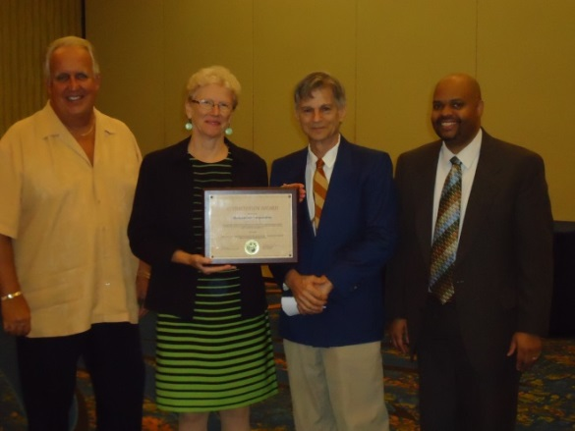
2014 Federal Fiscal Year Expenses

2013-14 Customer Satisfaction Survey
Final Results

[Cases Closed April 1, 2013 through March 31, 2014]
Florida Division of Blind Services (FDBS) Clients
Conducted for
the Florida Rehabilitation Council for the Blind

Beginning in 2004, the Florida Rehabilitation Council for the Blind decided to collect customer satisfaction data on a more “real time” basis. Rather than conduct one survey that included all of the clients who had their cases closed the preceding year, the Council decided to have the data collected on a monthly basis and review the results at their quarterly meetings. This report includes cases closed between April 1, 2013 and March 31, 2014. The Customer Satisfaction Survey of former Florida Division of Blind Services (FDBS) clients gathers perspectives of former FDBS clients concerning program services, levels of satisfaction, and areas for program improvement. This report describes the methods used and presents the 2013-14 results for clients with cases closed between April 1, 2013 and March 31, 2014. In the fall of 2009, the Florida Rehabilitation Council for the Blind modified the previous survey to streamline the interviews and update information in new areas. Some minor modifications to this survey were made October 2010. Many of the items remained comparable or identical to the survey administered the previous 9 years. In these instances, data for the 10 previous years are provided for comparison purposes. For new questions, major modifications made to question wording, or questions asked of different populations (new screens), no comparisons to prior years can be made.

SURVEY PROCEDURES

Population Surveyed. The Florida State University Survey Research Laboratory (SRL), College of Social Sciences, conducted a telephone survey of former Division of Blind Services (DBS) clients on a monthly basis. For the period between April 1, 2013 and March 31, 2014 there were a total of 1,894 employment-bound clients with cases “closed “ that comprises the population surveyed for this year-end report. DBS provided the names, addresses, phone numbers and demographic information for 1,257 former clients. Case closures are classified into two major groupings, those with successful and unsuccessful closures.

Overall Satisfaction

Client satisfaction with the DBS program is high. To gauge the overall level of satisfaction with the DBS program, former clients were asked if they would recommend FDBS services to others. During 2013-14, nearly all the clients, 95 percent (333 of 349), said, “Yes”, they would recommend DBS services to others. This is consistent with previous years’ results. Clients were also asked to rate their overall satisfaction with the program. During 2013-14, 87 percent of the clients (306 of 352) were either “Satisfied” or “Very Satisfied with the program. Complete Survey results can be found on the FDBS website: http://FDBS.myflorida.com

Florida Division of Blind Services
Performance and Employment Outcomes

Florida DBS VR Performance Based Budget Measures

DBS VR Performance Based Data | FFY2010 | FFY2011 | FFY2012 | FFY2013 | FFY2014
Number of Customers Served | 5782 | 5648 | 5455 | 5420 | 5366
Number of Customers Successfully Closed | 688 | 720 | 740 | 690 | 721

Consumers Earnings Data –Federal Fiscal Year

 | FFY2010 | FFY2011 | FFY2012 | FFY2013 | FFY2014
Average # of Hours worked per week | 31.17 | 30.51 | 30.60 | 30.35 | 29.64
Average Hourly Wage | $12.64 | $13.23 | $12.59 | $13.41 | $13.54
Average Weekly Wage | $396.28 | $382.29 | $395.64 | $410.07 | $399.85
Projected Average Annual Earnings at Placement | $20,606.48 | $19,879.06 | $20,573.15 | $21,323.76 | $20,792.15
Average Case Cost | $4,492.94 | $5,841.48 | $7,311.63 | $8,086.59 | $6,883.56

Florida Rehabilitation Council
for the Blind
Ad Hoc Committees

EXECUTIVE COMMITTEE

The Executive Committee shall consist of the Chair, First Vice Chair, Second Vice Chair and the Chairs of each standing committee. The Executive Committee is as follows:

Bruce Miles, Council Chair
Dwight Sayer, First Vice Chair
Joe Minichiello, Second Vice Chair
Sheryl Brown, Chair, Planning Committee
Paul Edwards, Chair, Evaluation Committee

PLANNING COMMITTEE

The Planning Committee will report to the full council regarding activities authorized to be carried out under Section 105 of the Rehab Act, as amended, and assist in the preparation of the State plan and amendments to the plan, applications, reports, and needs assessments required by Section 105 of the Rehab Act, as amended and other programs. The Planning Committee is as follows:

Sheryl Brown, Chair
Ben Grzesik
Paul Kaminsky
Joe Minichiello
Christopher White
Vicky Magliocchino
Lenora Marten

EVALUATION COMMITTEE

The Evaluation Committee will review, analyze, and report to the full council regarding the performance of the responsibilities of FDBS as required under Section 105 of the Rehab Act, as amended. The Evaluation Committee is as follows:

Paul Edwards, Chair
Donte Mickens
Dan O’Connor
Sylvia Stinson-Perez
Leanne Grillot
Gloria Mills
Dwight Sayer
Sandy Martin

TRANSPORTATION COMMITTEE

The Transportation Committee will report to the full council regarding the trends, and outcomes of paratransit as required under Section 105 of the Rehab Act, as amended. The Transportation Committee is as follows:

Gloria Mills, Chair
Sylvia Stinson-Perez
Dwight Sayer
Paul Edwards
Sandy Martin
Joe Minichiello

Florida Rehabilitation Council for the Blind Biographies

SHERYL K. BROWN
TAMPA

Sheryl Brown is one of the four Business/Industry representatives on the Florida Rehabilitation Council for the Blind.

Sheryl is the Executive Director of the Tampa Lighthouse for Blind, overseeing services in Polk, Hardee and Hillsborough Counties. She has a Master’s Degree in Visual Disabilities from Florida State University and has worked at the Lighthouse for 30 years.

Sheryl is active in her community and has served in the following areas: President-Elect, President and Past President of FAER, Secretary of Hillsborough Advocates for Improved Transit, Member of the Hillsborough County Alliance for Citizens with Disabilities, Member of the Agency Directors Council of United Way of Central Florida, Member of the City of Tampa, Mayor’s Alliance, Board Member of Career Source of Hillsborough County, and member of Project Connect Transition from School to Work for Hillsborough County. Also, she is a member of Florida Association of Agencies Serving the Blind, VisionServe, NIB and NAEPB.

Sheryl resides in Tampa and has been married to her husband for 31 years. They have one daughter.

≈ ≈ ≈ ≈ ≈ ≈ ≈ ≈ ≈ ≈ ≈ ≈ ≈ ≈ ≈ ≈ ≈ ≈ ≈ ≈

PAUL A. EDWARDS
MIAMI

Paul Edwards is an Advocacy Group representative on the Florida Rehabilitation Council for the Blind representing the Florida Council of the Blind (FCB).
Paul has held the position of the Director of Access Services at the North Campus of Miami-Dade College since 1986. He is responsible for providing services to approximately six hundred students each year who, because of their disabilities, need special accommodations at college.

Paul was born in San Francisco, California on December 29, 1945 and because of prematurity became totally blind by six weeks. At age seven his family moved to Canada. At the age of 13 his family moved to the island of Jamaica where he attended regular high school. At eighteen, he won an open scholarship to the University College of the West Indies, then a branch of the University of London, England. He graduated three years later with upper second-class honors and a special honors history degree. Paul’s next move was to Trinidad to attend the University of the West Indies, Institute of International Relations of Geneva, Switzerland where he met and married Helen Johnson and became a father.

Paul and his family returned to the United States in 1976 and eventually ended up in Daytona Beach, Florida where he began his work with blind people. In 1980 Paul became a Vocational Rehabilitation Counselor. In 1983 he moved to Jacksonville to become the director of a private agency serving the blind, Independent Living for the Adult Blind, which operated in conjunction with Florida Community College of Jacksonville. In 1986 Paul moved to Miami and assumed the position he has held since.

Paul became active in the Florida Council of the Blind in 1977. He was elected President of ACB in 1995 after serving a six-year term as First Vice President. He is currently Vice President of Library Users of America, is chair of the Board of Publications of ACB and is immediate Past President of the Florida Council of the Blind. He also serves on the Program Committee of the American Foundation for the Blind and is a member of the Board of Directors of the National Accreditation Council for Agencies serving the Blind and Visually Impaired.

Throughout his adult life Paul has been active in his community. He has produced radio programs for the Catholic Church; he has chaired a broad range of local and state disability committees; he has been active in promoting library services, access technology, and equitable transportation for people with disabilities and in particular, has worked tirelessly to improve education for children with disabilities.

Paul is an avid reader of science fiction and fantasy and is also a devotee of folk music. He continues to be fascinated with what technology can do. His latest special interest is audio on the World Wide Web. Paul has hosted a weekly program called Tuesday Topics on the internet for the ACB’S radio station on the Internet called ACBRADIO (http://www.acbradio.org).

Paul continues to work on blindness issues because, as he often says, “We have a responsibility to advocate for ourselves and to convince society that we have a right to fully participate at work and at play in our communities.”

≈ ≈ ≈ ≈ ≈ ≈ ≈ ≈ ≈ ≈ ≈ ≈ ≈ ≈ ≈ ≈ ≈ ≈ ≈ ≈

BENEDICT F. GRZESIK
MELBOURNE, FL

Ben Grzesik is the State Workforce Investment Board representative on the council.

Ben has extensive experience implementing strategic human resource and risk management departments and has served as a wealth analyst.

Currently on the Board of Workforce Florida, Inc. and is the Chair for the Finance & Administration Council; also serving on the Florida Rehabilitation Council for the Blind, the Florida Rehabilitation Council and most recently on the United States Department of Education, Primary Study Group for the 37th Institute on Rehabilitation Issues.

For the past ten years, he has been a member of the adjunct faculty in the virtual classroom for the University of Maryland University College teaching numerous Human Resources-related courses.

Ben holds a Master’s degree in International Administration and a
BA degree in Organizational Behavior and is certified as a Senior Human Resource Professional and a member of the Society for Human Resources Professionals.

≈ ≈ ≈ ≈ ≈ ≈ ≈ ≈ ≈ ≈ ≈ ≈ ≈ ≈ ≈ ≈ ≈ ≈ ≈ ≈

ROBERT KELLY
DAYTONA BEACH

Robert Kelly is one of four Business/Industry representatives on the Florida Rehabilitation Council for the Blind.

Robert Kelly is a Certified Rehabilitation Counselor who has more than 30 years of experience in direct service provision and administration of services for people who are blind and visually impaired. He currently serves as Executive Director of the Florida Lions Conklin Center for the Blind in Daytona Beach, Florida.
PAUL W. KAMINSKY
MIDDLEBURG

Paul Kaminsky is an Advocacy Group representative on the Florida Rehabilitation Council for the Blind representing the Blinded Veterans Association (BVA).

Paul is a past member of the Blinded Veterans Association (BVA) National Board of Directors. Currently, Paul is a Trustee BVA National Life Membership Fund, President BVA Florida Regional Group, Jr. Vice Commander, Disabled American Veterans Blind Veterans National Chapter and notably he currently serves as Vice-President, Clay County Chapter of the Florida Council of the Blind.

Paul is a Graduate of Boca Ciega High School, Gulfport, Florida, 1965.
Paul received his AS/EET from Florida Junior College in 1974. Paul also received his B.S.B.A., and LA from Jones College, Jacksonville, Florida (Summa Cum Laude) in 1998. Paul, a graduate of the Birmingham, Alabama Blind Rehabilitation Center, and 30-year Navy veteran 1965 to 1995, enlisted pay-grades held: E-1 through E-9. Paul’s Officer Ranks held: O-1 through O-5., blindness service connected.

Though Paul is legally blind, he remained on active, fit-for-full, duty 1987 to 1995.
Life Member: VFW, DAV, MOAA, BVA.

≈ ≈ ≈ ≈ ≈ ≈ ≈ ≈ ≈ ≈ ≈ ≈ ≈ ≈ ≈ ≈ ≈ ≈ ≈ ≈

SANDRA MARTIN
NORTH FORT MYERS

Sandra Martin is an Advocacy Group representative on the Florida Rehabilitation Council for the Blind representing the Florida Lions Club (LIONS).

Ms. Martin is a marketing representative and receptionist at the Lighthouse of SWFL in North Fort Myers, FL. Blind since the age of 22, “Sandy” lost her eyesight due to juvenile diabetes shortly after the birth of her daughter. This vibrant woman prides herself on being an active member of her community and always lives life to the fullest. Her love of life and dedication to helping others has made her the recipient of many awards and accolades including the Kenneth Shaw Goodwill International Award, Goodwill Graduate of the Year and Lion of the Year, just to name a few. “Sandy” spent most of her years living in Naples, Florida and her advocacy efforts were instrumental in bringing in more services for the blind to Collier County. One of her proudest achievements being the pivotal role she played as one of the founders of The Lighthouse of Collier. “Sandy” was also an active member with the Naples Lions Club and was main catalyst for the audio crosswalk beeper installation. Having relocated the North Fort Myers area, Sandy remains active in her outreach and advocacy efforts and continues to promote the importance of rehabilitation services for the blind throughout Lee, Hendry and Glades Counties.

≈ ≈ ≈ ≈ ≈ ≈ ≈ ≈ ≈ ≈ ≈ ≈ ≈ ≈ ≈ ≈ ≈ ≈ ≈ ≈

VICTORIA A. MAGLIOCCHINO
ST. AUGUSTINE

Victoria Magliocchino is an Advocacy Group representative on the Florida Rehabilitation Council for the Blind representing the Florida Deaf-Blind Association (FDBA).

Vicky was born at an army base in Columbus, Georgia and grew up in Thornwood and Hawthorne, New York. She attended New York School for the Deaf from 1961 to 1975, Gallaudet University in Washington, D.C. from 1975 to 1979, and Western Maryland College (currently McDaniel College) in Westminister, Maryland in the summers of 1980, 1981, and 1982. She earned her BA in English from Gallaudet and MA in Deaf Education from Western Maryland.

Vicky has taught language arts and mathematics at the Deaf Department High School at Florida School for the Deaf and Blind in St. Augustine for 35 years. She was the head sponsor of the Junior National Association of the Deaf 1979 to 1987. She also was the school yearbook advisor/journalism teacher for 12 years. She retired this past May.

She has served FDBA as the president for the past 7 years. She was instrumental in establishing FSSP (Florida Support Service Providers) project and hopes it will become a full-blown program in the near future to provide much needed SSP services to the Deaf-Blind community. She received 2013 SERID Outstanding Deaf/Hard of Hearing/Deaf-Blind.
Vicky has three grown children. She was married for 21 years.

ROBERT LEE DOYLE, III
TALLAHASSEE

Robert Lee Doyle, III was appointed the Director of the Division of Blind Services on June 20, 2013.

Robert has served for four years as director of the Division for the Visually Impaired within the Department of Human Services in Delaware. He has 15 years of experience in human services and education and holds a bachelor’s degree in political studies and a master’s degree in public administration, both from the University of Illinois. Among other achievements, he has implemented initiatives that resulted in increased successful employment outcomes through the VR program and has also worked to expand food service and vending business opportunities through Delaware’s Business Enterprise program.

Robert places a high priority on customer service, accountability, and positive relations with consumer groups and other stakeholders.

≈ ≈ ≈ ≈ ≈ ≈ ≈ ≈ ≈ ≈ ≈ ≈ ≈ ≈ ≈ ≈ ≈ ≈ ≈ ≈

DONTÉ A. MICKENS
DELRAY BEACH

Donte’ Mickens is a Former Client representative on the Florida Rehabilitation Council for the Blind. Donté is a graduate of Florida State University where he received a Master of Science degree in Management with a major in Risk Management/Insurance and Bachelors of Science Degrees in Finance and Risk Management. He is also a graduate of the Florida School for the Deaf and Blind in St. Augustine, FL.

Donté previously worked for the Division of Blind Services as an analyst, primarily assisting the Division’s budget officer. He also mentored fellow university students and Division clients in previous years.

Donté is a member of the Board of Directors for the National Organization for Albinism and Hypopigmentation (NOAH). He also serves as the organization’s treasurer.

Donté is a Paralympic medalist as a member of the Men’s U.S. National Goalball team, competing in the Paralympic Games in Athens, Greece and Beijing, China. He currently lives and works in the Delray Beach/Boca Raton area as a Senior Financial Analyst with NCCI, Inc.
BRUCE A. MILES
MARCO ISLAND

Bruce Miles represents the Parent of Blind on the Florida Rehabilitation Council for the Blind.

Bruce moved to Florida from Chicago Illinois in 1972, along with his wife, Sheila and son Troy. He has been actively engaged in the Real Estate Business on Marco Island since 1974. Bruce owned and operated Gulf Coast Realty of Marco Inc. for many years and now associated with Anchor Real Estate of Marco.

Bruce is currently the chair of the Florida Rehabilitation Council for the Blind and treasurer of the Blind Services Foundation. He is a charter member and past president of Marco Island Area Association of Realtors. He was past president of Marco Island Multi List Inc. He has served on many committees with the Florida Association of Realtors (FAR) and was chairman of The Professional Standards and The Resort and Second Home committees.

Bruce was very active on the local level, including director of The Marco Island Fair Water Defense Fund committee (negotiating a buy out of the local water utility). He is a three term past president of the Marco Island Lions Club, currently serving as their Tail Twister and a Board Member. He is the past director on the board of the Lighthouse of Collier.

Bruce Miles is no stranger to The Division of Blind Services, he served on their advisory council from 1985 to 1995 and then on Fl. Rehab Council for the Blind from 1995 to 2001. His current appointment was made October 2008.

In his spare time Bruce enjoys travel (particularly cruising), swimming, boating and cooking.

JOSEPH B. MINICHIELLO
JACKSONVILLE

Joe Minichiello is one of the four Business/Industry representatives on the Florida Rehabilitation Council for the Blind.

Joe received his Bachelor’s Degree in history from Binghamton University in 1993. In 1995 he was hired by the Internal Revenue Service and moved to Jacksonville, Fl. He is currently serving as President of the National Federation of the Blind Greater Jacksonville chapter and Second Vice President of the National Federation of the Blind of Florida.

Joe was born and raised in Watkins Glen, New York. He is married and has worked actively in the community for many years to improve the lives of individuals who are blind.

≈ ≈ ≈ ≈ ≈ ≈ ≈ ≈ ≈ ≈ ≈ ≈ ≈ ≈ ≈ ≈ ≈ ≈ ≈ ≈

DANIEL W. O’CONNOR
JACKSONVILLE

Dan O’Connor is the VR Counselor representative on the Florida Rehabilitation Council for the Blind.

Dan has been working for Division of Blind Services (FDBS) for about 4 ½ years since July, 2005 as a Senior Rehabilitation Specialist in Jacksonville / District 3. His current caseload is mostly working with the Transition (high school students). He is a Certified Rehabilitation Counselor, and has a master’s degree in mental health counseling.

Dan is actively involved in many disability and advocacy groups such as the Jacksonville Mayor’s Disability Council, Jacksonville Human Rights Commission, Duval County Transportation Disadvantaged Coordinating Board, Duval County Elections Advisory Panel, and the First Coast Disability Advocates.

Dan is also a past president of the Jacksonville Council of the Blind, and has a good relationship with both the local ACB & NFB chapters. He takes an interest in community issues, and believes in empowering the disadvantaged and encouraging independence and community integration.

LEANNE GRILLOT
TALLAHASSEE

Leanne Grillot is the State Educational Unit (IDEA) representative on the Florida Rehabilitation Council for the Blind.

Since 2011, Leanne Grillot has been working for the Bureau of Exceptional Education and Student Services as a specialist for programs serving students who are visually impaired, deaf/hard of hearing, and dual-sensory impairments. Ms. Grillot has extensive experience as a teacher of the visually impaired and orientation and mobility specialist having been in the field for 20 years. Additionally, Mrs. Grillot assists with questions regarding assistive technology, Florida Alternate Assessment, National Instructional Materials Access Standard, and Online Learning for Students with Disabilities.

≈ ≈ ≈ ≈ ≈ ≈ ≈ ≈ ≈ ≈ ≈ ≈ ≈ ≈ ≈ ≈ ≈ ≈ ≈ ≈

JESUS GARCIA
MIAMI

Jesus is one of four Business/Industry representatives on the Florida Rehabilitation Council for the Blind.

Jesus is employed with LogistiCare, a company specializing in transportation. LogistiCare provides management services for government and private transportation systems. He graduated from Florida State University with a Bachelor in Science and Business Administration and a Minor in Computer Science. Hobbies include reading, music, politics, and all fields in the sciences. Jesus has been totally blind since birth and is active in the blind consumer movement, a member of the Florida Council of the Blind and its parent organization the American Council of the Blind.

GLORIA MILLS
TAMPA

Gloria is one of four Business/Industry representatives on the Florida Rehabilitation Council for the Blind.

After twenty-four years with the Internal Revenue Service, Gloria retired and started her own business as an Enrolled Agent/Tax Consultant in 1996. An EA is granted a license to represent taxpayers in matters of IRS Collections or Examinations as well as in tax court. Gloria enjoys working in the community on causes relating to disabilities or transportation. In 1999 Gloria served on the Committee of ninety-nine representing consumers. Gloria is proud to have the honor of being awarded the 1000 Points of Light Award by former state of Florida Governor Jeb Bush. One of Gloria’s most notable accomplishments is that she purchased the building in which she operates her company in 2008. Gloria has served on various Boards of Directors, including the Florida Alliance for Assistive Services and Technology (FAAST), NAWBO, NFB and Self-Reliance, Inc.

≈ ≈ ≈ ≈ ≈ ≈ ≈ ≈ ≈ ≈ ≈ ≈ ≈ ≈ ≈ ≈ ≈ ≈ ≈ ≈

DWIGHT D. SAYER
CLERMONT

Dwight is one of four Business/Industry representatives on the Florida Rehabilitation Council for the Blind.

Dwight is a Strong blind advocate and is currently serving as president of the National Association of Blind Veterans/A Division of the NFB, First Vice President of the National Federation of the Blind of Florida, Past President of the Greater Orlando Chapter, state registrar for NFB Newsline-reg, Past President of the Ocoee Lions Club, life member of the Alumni Association of the VA’s Southeastern Blind Rehab Center in Birmingham, Ala., a life member of the Blinded Veterans Association, a life member of the Disabled American Veterans, a Director on the Board of Lighthouse Central Florida, a Past Director on the Board for the Central Florida Center For Independent Living.

Dwight holds a BS and MS in Business Administration. He was Honorably/Medically Discharged from the Air Force in 1969.

Dwight was awarded the West Orange Community Champion of the Year Award presented by the West Orange Chamber of Commerce in 2006.

In his spare time, Dwight holds down a full time job with MV Transportation, Inc. as their Community Relations Manager and is responsible for activities from coast to coast that impact the disabled communities they serve.
Prior to his current responsibilities, he was medically retired, due to blindness, from his position as national traffic and logistics manager at Aftermarket Technology Corp., where he created and led the transportation systems of this worldwide automotive parts supplier based in Chicago, Ill., with annual sales of $760 million.
Dwight also volunteers his time at St. Paul’s Presbyterian Church, the Orlando VA Medical Center and is a past wish granter for the Make-A-Wish Foundation of Northeast Ohio.
Dwight was born in Rochester, N.Y., and raised in Orlando. He now lives in Winter Garden, Florida with his wife Patty and two children, Austin and Amanda, and their pet dog, Pearl.
≈ ≈ ≈ ≈ ≈ ≈ ≈ ≈ ≈ ≈ ≈ ≈ ≈ ≈ ≈ ≈ ≈ ≈ ≈ ≈

SYLVIA STINSON-PEREZ
PORT RICHEY

Sylvia Stinson-Perez is the Community Rehab Center representative on the Florida Rehabilitation Council for the Blind.

Sylvia is the Executive Director of the Lighthouse for the Visually Impaired and Blind (LVIB), which serves Pasco, Hernando and Citrus Counties. She has over 12 years in the field of vision rehabilitation. She has Master’s degrees in Social Work and in Visual Disabilities from Florida State University. She is actively involved in Florida Association of Education and Rehabilitation for the Blind and Visually Impaired.

Sylvia is herself visually impaired, and it is one of her goals to ensure that persons who are blind or visually impaired receive the training that will ensure they will live independent and successful lives, and to help the general community realize that persons who are blind can be and are competent, normal, successful people.

Sylvia is the proud mother of Olivia, 15 years old, and a guide dog named Carmel.

LENORA MARTEN
JACKSONVILLE

Lenora Marten is the Parent Training Center representative for the Florida Rehabilitation for the Blind.

Lenora currently volunteers within the blind community by serving as president, Florida Organization of Parents of Blind Children and secretary, National Federation of the Blind.

Lenora believes that given the opportunity, education, and tools to succeed, blind people can lead independent, productive lives.

Lenora resides in Jacksonville, Florida with her husband and son. She is an accomplished cosmetologist specializing in color and design.

≈ ≈ ≈ ≈ ≈ ≈ ≈ ≈ ≈ ≈ ≈ ≈ ≈ ≈ ≈ ≈ ≈ ≈ ≈ ≈

CHRISTOPHER WHITE
RIVERVIEW

Christopher White is the representative for the Client Assistance Program on the Florida Rehabilitation Council for the Blind.

Christopher White is the Managing Attorney for the Employment Team at Disability Rights Florida, Inc. Disability Rights Florida is the Protection and Advocacy system for the State of Florida and houses the Client Assistance Program. A graduate of the University of Florida and Chicago-Kent College of Law, Mr. White resides in Land O’ Lakes with his wife and two children.

PATRICIA LIPOVSKY
DAYTONA BEACH

Patricia Lipovsky is the representative for the Representative for the Florida Independent Living Council on the Florida Rehabilitation Council for the Blind.

She is originally from New Jersey, which is where she received her education, got married, and started a family. Patricia is a proud mom of three children, and six grandchildren. Although she considers herself to be retired for the most part, she enjoys dabbling in real estate, along with property management, which she has done for several years. She also advocates for people with disabilities throughout the state of Florida, encouraging Equal accessibility and Opportunity for all.

In addition to serving on the FRCB council, Patricia also serves on the Florida Independent Living Council (FILC), is the Treasurer of the Handicapped Adults of Volusia County (HAVOC), and the President of the Coalition and Concerns of the Totally Blind (CCTB.) In addition to her role on several committees in her local community, she also serves as a board member on the Friends of Library Access, which supports the Braille and Talking Books Library in Daytona Beach in providing audio books to the print impaired throughout the State of Florida, and sits on two state committees of the Florida Council of the Blind.

Patricia’s major in college was Psychology and Business, with a mission to help people, wherever and whenever she can. Her favorite quotes are “Where There Is a Will, There Is a Way”, and “If God brings you TO it, he will bring you THROUGH it.” No matter what the challenge or obstacles are, we must never give up.” “There is always a solution; we just need to find it.”
≈ ≈ ≈ ≈ ≈ ≈ ≈ ≈ ≈ ≈ ≈ ≈ ≈ ≈ ≈ ≈ ≈ ≈ ≈ ≈

CONNECT WITH DBS

http://DBS.myflorida.com/

Florida Rehabilitation Council for the Blind
Florida Department of Education
Administrative Offices
325 West Gaines Street
Tallahassee, FL 32399
850-245-0300 • 1-800-342-1828

