Florida
Rehabilitation
Council
for the
Blind

2019 Annual Report

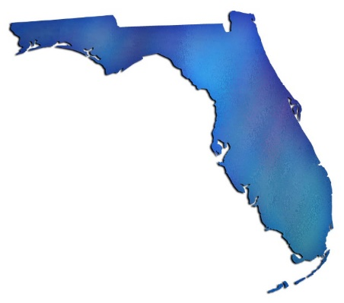

Enclosed is a copy of the Florida Rehabilitation Council for the Blind’s (FRCB) Federal Fiscal Year 2019 Annual Report to the Commissioner of the Rehabilitation Services Agency and Governor Ron DeSantis.

Please contact Government Operations Consultant to the FRCB Selena Sickler if you have questions or comments regarding its contents. She can be reached at:
Florida Division of Blind Services
325 W. Gaines Street, Room 1114
Tallahassee, FL 32399
Phone (850) 245-0329
Selena.Sickler@dbs.fldoe.org

Thank you for your interest in and support of programs that provide and promote the use of vocational rehabilitation and independent living programs for Floridians who are blind or visually impaired.

If you would prefer a copy of this report in an alternative format, please contact the Florida Division of Blind Services at (850) 245-0300 or toll-free at (800) 342-1828.

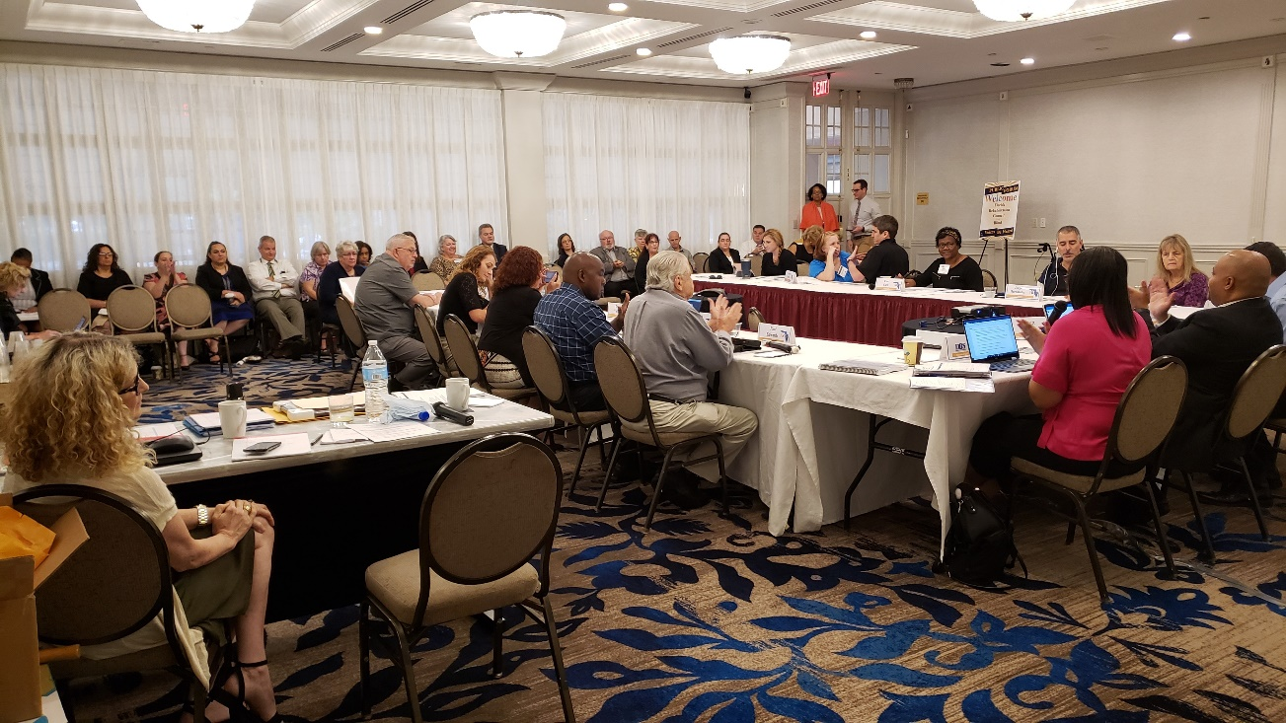
FRCB Quarterly Meeting

Table of Contents

Message from the Chairperson 6
Director’s Message 7
FRCB Mission 8
2018-2019 Council Members & Bios 9
DBS Mission Statement 17
Accomplishments 18
Strategic Plan Goals 20
DBS District Offices 21
Quarterly Meetings and Public Forums 22
2018-2019 Meeting Dates and Locations 22
Employer Recognition 23
Expenses 26
Customer Satisfaction Survey (2018-2019) 27
Outcomes 29
DBS Cases Achieving Employment 30
Committees 31
How to become a FRCB Member 32

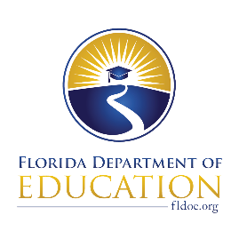
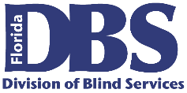
Florida Rehabilitation Council
For the Blind

December 4, 2019

U. S. Department of Education, OSERS
Rehabilitation Services Administration
Attn: Mary Williams
400 Maryland Avenue SW
Washington, DC 20202-2800

Dear Ms. Williams:

The Florida Rehabilitation Council of the Blind respectively submits its 2019 Annual Report as required by Section 105(C) (4) of the 1992 Amendment to the Rehabilitation Act. In accordance with 34 CFR 361.17, a copy of this report has been submitted to the Florida Governor’s Office.

This report presents our activities and recommendations for the 2018-2019 federal fiscal year to the Florida Division of Blind Services.

As the chair of the council, I would like to offer my appreciation and gratitude to the Division of Blind Services for its excellent support, and the council members for their diligence and contributions in serving Floridians with visual impairments.

If you have questions regarding this submission, please contact Selena Sickler assistant to the council at 850/245-0329.

Sincerely,

Michael Wiseman, Chair
Florida Rehabilitation Council for the Blind

MW/ss

cc: Governor Ron DeSantis
Christyne Cavataio

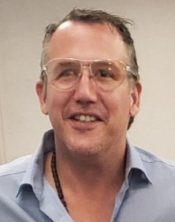
The Florida Rehabilitation Council for the Blind (FRCB) is pleased to present its annual report for Federal Fiscal Year 2019 to the governor and other committed stakeholders. In 2019, there was an increased effort on collaboration, planning and advocacy on the part of the Council and the Division of Blind Services (DBS) in order to improve employment outcomes for Floridians who are blind or have low vision.

Message from the Chairperson

The FRCB elected new officers on February 5: Michael Wiseman was elected Chairman, Dwight Sayer was elected as Vice-Chair, and Denise Valkema was elected as 2nd Vice-Chair. The FRCB had six appointments and two reappointments in 2019: Misty Porter, representing the Parent Training and Information Center; Kim Carr, representing Business and Industry; Leanne Grillot, representing the State Educational Agency; Tracie Inman, representing the Deaf/Blind; Jorge Hernandez, representing Community Rehabilitation Providers; Dwight Sayer, representing Business and Industry; Louise Peyton, representing Vocational Rehabilitation Counselors; and Paul Edwards, representing Business and Industry. The Council continues to encourage appointees to apply and monitors action by the Governor’s office to encourage timely appointments and reappointments. Recruiting new applicants will focus on individuals who are passionate, dedicated, and interested in improving the lives of visually impaired individuals.

The FRCB has worked closely with DBS in tracking employment outcome information and will continue to do so. We are pleased that DBS is able to report significant improvement in this core area of its responsibilities.

The FRCB has continued to meet quarterly at key locations around the state to highlight the accomplishments of the agency and maintain awareness about issues related to DBS regional service offices and community rehabilitation programs. The FRCB is required to hold a public forum at their quarterly meetings at least twice a year, but three are generally held. For the FFY 2018-2019, the FRCB held four public forums. The public forum gives consumers around the state a voice, allowing them to provide input that encourages optimal services.

Mikey Wiseman
FRCB Chairman

The Florida Division of Blind Services (DBS) has enjoyed a successful year by providing services for FFY 2018-2019 to 4,997 customers and helping 878 individuals gain, maintain, or advance in successful employment. These accomplishments are a collaborative effort of staff, providers, advocates, and stakeholders.

Director’s Message

The Florida Rehabilitation Council of the Blind (FRCB) continues to develop a strong partnership with DBS to assist in the common goal of maximizing employment and independent living for people who are blind or have low vision.

DBS has had a successful year helping more clients than ever achieving or maintaining successful employment goals. Moreover, the Division has strengthened key partnerships with contractors and other key stakeholders.

The Division of Blind Services will continue to build on its successes through collaboration and communication with core partners as we remain focused on delivering quality services for Floridians in the blind or visually impaired community.

Robert L. Doyle, III
Director Division of Blind Service

FRCB Mission
The Florida Rehabilitation Council for the Blind reviews, analyzes, and advises on policy decisions and evaluates the effectiveness of the Florida Division of Blind Services to ensure meaningful access to and use of vocational rehabilitation and independent living programs for Floridians who are blind or visually impaired.

Vision Statement

The Florida Rehabilitation Council for the Blind functions to create a positive impact on the fairness, efficiency, and accessibility of services through the evaluation of consumer feedback and the Florida Division of Blind Services’ performance.

Council Composition

- Independent Living Council (FILC)
- Parent Training & Information Center
- Client Assistance Program (CAP)
- VR Counselor (ex officio if staff)
- Community Rehabilitation Program Service Provider (CRP)
- A former applicant or client of VR services (two seats)
- State Educational Agency (IDEA)
- Parent, family member, guardian, advocate, or an authorized representative of a blind person.
- State Workforce Investment Board (SWIB)
- Four with Business, Industry & Labor
- Disability Advocacy Groups
- Director of Division of Blind Services (Serves Ex-Officio Member)
- One Division of Blind Services (FDBS) employee serves as the Council’s staff

Nicole Attong, LMHC

2018-2019 Council Members & Bios
Director of FIU Embrace Florida Independent Living Council
Nicole Attong is the Florida Independent Living Council representative for the Florida Rehabilitation Council for the Blind.

Nicole is a Licensed Mental Health Counselor with more than 15 years of experience working with children, youth, and families in the human services field in Miami-Dade and Monroe counties. Ms. Attong graduated with an M.A. in Mental Health Counseling and has spent her career working for underserved populations. She has served in leadership positions in both the child welfare and mental health and substance abuse systems in Miami-Dade County and was also the Executive Director for the Community Based Care Alliance. Ms. Attong has experience in capacity building, implementing evidence-based practices and convening solution-focused groups of providers, stakeholders, and constituents around social justice issues. She has also served as the Project Director for the evaluation of the child-welfare system in the Southern Region, and two federally-funded systems of care grants in Miami. Currently, Ms. Attong serves on two national workgroups aimed at improving the mental health and well-being of children, youth, and families. She is a member of the Community Based Care Alliance Board, the Humana Behavioral Health Practitioner Advisory Panel for the Autism Spectrum Disorder Center of Excellence, the Commission on Disability Issues and the Florida Independent Living Council.

Howard Bell
St. Petersburg Client Assistance Program
Howard Bell is the Client Assistance Program representative for the Florida Rehabilitation Council for the Blind.

Howard has served as a Senior Advocate Investigator with Disability Rights Florida since 2002. He earned an Associate of Arts degree from Santa Fe Community College and a Bachelor of Science degree in Psychology from Florida State University. He is a certified DUI instructor by the Florida Department of Highway Safety and Motor Vehicles. He has served on the National Disability Rights Network’s Client Assistance Program Advisory Committee. He now serves on the Committee to Advocacy for Persons with Impairment for the City of St. Petersburg, the Professional Advisory Committee and the RSA Scholarship Project Advisory Committees at the University of South Florida.

Kim Carr
Jacksonville Business/Industry/Labor
Kim Carr is a Business/Industry representative on the Florida Rehabilitation for the Blind.

Kim Carr, Director of Early Intervention for the Blind and Visually Impaired at the
Florida School for the Deaf and the Blind, has worked in the education field as an Early Childhood Educator since 2001 and in the field of Early Intervention for children with visual impairments since 2006. She has over 17 years of experience working with young children and their families in the classroom and in the home environment.

Kim has her Bachelors of Arts in Early Childhood Education, Masters of Arts in Educational Leadership and a certificate in Visual Disabilities, Early Intervention.

Rose Conry
Jacksonville State Workforce Investment Board
Rose Conry is the CareerSource representative on the Florida Rehabilitation Council for the Blind.

Ms. Conry is the Chief Executive Officer and co-founder of Stafftime, an award-winning full-service staffing company based in Jacksonville. Ms. Conry is a member of the Jacksonville Chamber of Commerce and is active on a number of affiliated boards. She lives in Orange Park.

Robert L. Doyle, III
Tallahassee Director, Division of Blind Services
Robert Lee Doyle, III was appointed the Director of the Division of Blind Services on June 20, 2013.

Mr. Doyle served for four years as director of the Division for the Visually Impaired within the Department of Human Services in Delaware, prior the joining the Florida Division of Blind Services. He has over 20 years of experience in public service, including roles in human services education public policy. Director Doyle holds a Bachelor’s Degree in Political Studies and a Master’s Degree in Public Administration, both from the University of Illinois-Springfield. Among other achievements, he has implemented initiatives that resulted in increased successful employment outcomes through the Vocational Rehabilitation program and worked to expand foodservice and vending business opportunities through Delaware’s Business Enterprise program.

Mr. Doyle places a high priority on customer service, accountability, and positive relations with consumer groups and other stakeholders.

Paul Edwards
Miami Business/Industry/Labor
Paul Edwards is one of the representatives of business and/or industry on the Florida Rehabilitation Council for the Blind.

A native of San Francisco, Paul Edwards was born with very little light perception, which soon led to total blindness. He graduated from high school and completed his bachelor's degree in history with special honors at the Mona Jamaica campus of the University of the West Indies. He was the first blind student to attend the college. He later earned his graduate degree in international relations.

Mr. Edwards taught at a small school in the rural area of Trinidad. After one year, he became the senior history master at Trinity College, the leading Anglican School for Boys in Trinidad and Tobago. Near the end of his teaching career, he earned a graduate degree in education from the University of the West Indies in St. Augustine, Trinidad. When he left Trinidad, he moved to Florida where he worked for the Division of Blind Services as a rehabilitation teacher. In this job, he went to homes and taught people skills that would enable them to adjust to visual impairment. After three years, he became a rehabilitation counselor and worked mostly with high school and college students. In 1983, he moved to Jacksonville to take over as executive director of an agency serving the blind. In 1986, he moved to Miami to serve as the Director of Services to Students with Disabilities on the North Campus of Miami-Dade College, where his staff served more than 700 disabled students a year. He retired in May of 2012.

He has worked at the local, state, and national levels to advocate for persons who are blind. Mr. Edwards currently serves on the Florida Rehabilitation Council for the Blind, the National Accreditation Council Board, and holds several positions within the American Council for the Blind and its Florida affiliate.

Leanne Grillot
Tallahassee State Educational Agency
Leanne Grillot serves as the state educational agency representative on the Florida Rehabilitation Council for the Blind.

Leanne Grillot serves as the Senior Educational Program Director in the Dispute Resolution and Monitoring Section of the Bureau of Exceptional Education and Student Services (BEESS) within the Florida Department of Education. She is responsible for the development, dissemination, and tracking of the exceptional student education policies and procedures and assisting districts with the completion of these documents.

Ms. Grillot directs, coordinates and administers all aspects of monitoring and conflict resolution, including the state complaint investigation system, dispute resolution, state-facilitated individual educational plan meetings, and the mediation process. Ms. Grillot collaborates with families, school district personnel and agency representatives to ensure that Florida’s educational programs meet the needs of all students.

Before accepting this position in the bureau, Ms. Grillot was an Educational Program Director for the Dispute Resolution and Monitoring Section and a Program Specialist for students with sensory loss. Before joining the bureau, Ms. Grillot worked for over 20 years in three of the largest states as a teacher of students who have a visual impairment and as an orientation and mobility specialist. Ms. Grillot is currently pursuing her Doctorate of Philosophy in Special Education with a concentration in students who have a visual impairment.

Jorge Hernandez
Miami Community Rehabilitation Provider
Jorge Hernandez serves as the Community Rehabilitation Provider on the Florida Rehabilitation Council for the Blind.

Jorge Hernandez is employed at Miami Lighthouse for the Blind and Visually Impaired and is the current Manager of Technologies. After spending nearly two decades working in an institution of higher learning in the technology and accessibility field, he understands the needs and necessities of blind individuals who are seeking employment or the struggles of students on a campus environment. Mr. Herndandez believes it’s important to connect well with the people you are trying to help and communicate your understanding with personal experiences.

Hernandez has landed coverage in print and broadcast outlets in the Miami-Dade County area, including TV Marti en Español and the local CBS affiliate. Jorge has extensive Adaptive Technology experience; in addition, he is a member of the board of directors for the National Federation of the Blind of Florida (NFBF) and president of the local Miami-Dade Chapter of NFBF.

Jorge holds a B.S. in Information Technology with a minor in Business Management from Florida International University.

Tracie Inman
Jacksonville Deaf/Blind Advocate
Tracie Inman serves as the deaf/blind advocate on the Florida Rehabilitation Council for the Blind.

Tracie Inman is an advocate for the deaf/blind who has worked on the Principal's Advisory Council of the Florida School for the Deaf and the Blind. Additionally, Tracie worked with the Florida Department of Education and a team of other statewide experts during a rule revision development to define "deaf-blind" for the purpose of education of students who have combined loss of hearing and sight.

Ms. Inman has served in various roles in the Deaf-Blind Division of the National Federation of the Blind. She also served on the board of the Florida Association of Guide Dog Users. Additionally, Tracie has served as a charter member of the Florida Deaf-Blind Association. She is currently serving on the Advocacy Committee of the NFB of Florida in the Greater Jacksonville Chapter.

Ms. Inman is also a member of the National Independent Living Council (NILC). She attended the 2018 NICL Conference and "Day On the Hill" meeting with numerous aides to congressional leaders alongside Executive Director Tyler Morris of the Independent Living Resource Center (ILRC) of Northeast Florida and other members of ILRC and NICL.

She has been employed with the ILRC of Northeast Florida for four and a half years; serving as the Information & Referral Specialist since June of 2018. Ms. Inman assisted the Florida and Virgin Island Deaf-Blind Collaboration, the Helen Keller National Center, and other advocates in successfully advocating with the Department of Vocational Rehabilitation (DVR) for the establishment of a deaf-blind liaison to better serve the needs of clients who have combined loss of vision and hearing.

Robert Kelly
Daytona Beach Business /Industry/Labor
Robert Kelly is one of four representatives from business/industry on the Florida Rehabilitation Council for the Blind. He was reappointed by the governor on September 21, 2016.

Mr. Kelly is a certified rehabilitation counselor with more than 30 years of experience in direct service provision and administration of services for people who are blind and visually impaired. Mr. Kelly currently serves as executive director for the Florida Lions Conklin Center for the Blind in Daytona Beach, FL.

Paul Kurtz
Jacksonville Former Client
Paul Kurtz serves as a former client representative on the Florida Rehabilitation Council for the Blind.

Paul Kurtz was born in Jacksonville, Florida in March 1952. He attended public schools in Duval County, graduating with honors from Robert E. Lee High School in 1970. He went on to attend Florida Southern College, graduating with honors in 1974 with a B.A. in psychology. He then attended Florida State University, graduating in 1977 with an M.S. Degree in counseling, health, and rehabilitative services. Mr. Kurtz later earned an A.S. Degree from Florida State College in computer science.

During his career, Mr. Kurtz has served as a rehabilitation instructor, equal employment opportunity (EEO) specialist (counselor) for the Department of the Navy, a computer programmer, analyst, and a systems administrator.

Mr. Kurtz believes that concerned and capable people can indeed make a difference and has been a strong believer in community service since earning the rank of Eagle Scout and volunteering on other projects in high school. He has served as chairman of the Jacksonville Mayor’s Disability Council, chair of the Captain’s EEO Advisory Committee at the Fleet Readiness Center in Jacksonville, and on the Florida Rehabilitation Council previously.

Patricia Lipovsky
Daytona Beach Former Client
Patricia Lipovsky is a former client representative on the Florida Rehabilitation Council for the Blind.

A native of New Jersey, Ms. Lipovsky advocates for people with disabilities throughout the state of Florida and in her local community, encouraging equal access and opportunity for all. Patricia’s college majors were business and psychology. She is the proud mom of three children and six grandchildren. Although she considers herself to be retired for the most part, she enjoys dabbling in real estate and property management, which she has done for several years.

In addition to serving on the FRCB, Patricia has served as a member of the Florida Independent Living Council (FILC) for several years, as the president and treasurer of the Handicapped Adults of Volusia County (HAVOC), and as the president of the Coalition and Concerns of the Totally Blind (CCTB.) In addition to her role on several committees in her local community, she also serves as a board member of the Friends of Library Access, which supports the Braille and Talking Book Library in Daytona Beach by providing audiobooks to the print-impaired throughout the state of Florida. Ms. Lipovsky is a member of the Lions Club and sits on two state committees of the Florida Council of the Blind.

Her mission is to help people, wherever and whenever she can. Her favorite quotes are “Where there is a will, there is a way,” and “If God brings you to it, he will bring you through it.”

Bruce A. Miles
Marco Island Parent of Blind
Bruce Miles serves as a representative of parents of blind children on the Florida Rehabilitation Council for the Blind.

Mr. Miles moved to Florida from Chicago, Illinois in 1972 along with his wife, Sheila, and son, Troy. He has been actively engaged in the real estate business on Marco Island since 1974. Mr. Miles owned and operated Gulf Coast Realty of Marco Island for many years and is currently associated with Anchor Real Estate of Marco Island.

In addition to serving on the FRCB, Mr. Miles is also the treasurer of the Blind Services Foundation of Florida. He is a charter member and past president of the Marco Island Area Association of Realtors and a past president of Marco Island Multi List Inc. Mr. Miles has served on many committees with the Florida Association of Realtors (FAR) and was chair of The Professional Standards and The Resort and Second Home Committees.

He has been very active at the local level, including his service as the director of The Marco Island Fair Water Defense Fund committee, which negotiated a buyout of the local water utility. He is a three-term past president of the Marco Island Lions Club, currently serving as a board member and tail twister. He is the past director on the board of the Lighthouse of Collier.

Mr. Miles is no stranger to the Florida Division of Blind Services. He served on its advisory council from 1985 to 1995 and then on Florida Rehab Council for the Blind from 1995 to 2001. His current appointment was made on July 6, 2016.

Louise Peyton
Tampa Counselors
Louise Peyton is the representative for counselors on the Florida Rehabilitation Council for the Blind.

Ms. Peyton retired from the Division of Blind Services after working as a rehabilitation specialist for 36 years. She is a resident of Tampa who desires to continue to serve her community and state. Ms. Peyton expects to learn more about services to the blind and visually impaired residents of Florida and to aid with the continuation of those services.

Misty Porter
St. Augustine Parent Training and Information Center
Misty Porter serves as Parent Liaison for the Florida School for the Deaf and the Blind (FSDB) in St. Augustine, Florida. She relocated her family in 2009 after determining Florida to be the best state in the nation to raise her young child with vision loss.

Through her employment at FSDB, Misty is able to support her passion for working with families of children with sensory loss. Ms. Porter works with a variety of stakeholders to assure that families are aware of and have access to the necessary information, supports, and resources to promote the achievement of student academic goals and lifelong learning.

Ms. Porter has more than a decade of experience working with families of young children with exceptional needs and has a passion for supporting early intervention and early learning programs. Before joining the team of experts at FSDB, Ms. Porter was employed as a service coordinator through the Early Steps Program. She currently services on the Florida Coordinating Council for Infants and Toddlers, an advisory council for the Florida Early Steps Program. Ms. Porter serves on the Child and Family Outcomes workgroup for Children’s Medical Services and as a stakeholder provides strategic programmatic recommendations to support positive outcomes for Florida families.

Ms. Porter is a State Certified trainer for INSITE and VIISA curriculums and provides training and information to professionals in early intervention working with families of children with sensory loss. She is a Parent Advisor with the Parent-Infant Program at FSDB and often provides additional training for her peers and coworkers.

Her degree in Sociology from Valdosta State University prepared Ms. Porter to understand how social-based organizations work and to apply that knowledge to support the families and communities that she serves. Ms. Porter partners with education and resource-based programs throughout the state. She often presents at conferences and workshops such as Florida’s Family Café and EHDI (Early Hearing Detection & Intervention). As a mother of three children, two of whom have vision loss, Ms. Porter understands firsthand the positive impact a strong community, rich with quality programs, and accomplished mentors can have on the success of the upcoming youth in the blind community.

Dwight Sayer
Clermont Business/Industry/Labor
Dwight Sayer is a representative for Business/Industry/Labor on the Florida Rehabilitation Council for the Blind.

Prior to losing his vision, Dwight D. Sayer worked as the National Traffic and Logistics Manager at Aftermarket Technology Corp. There, he created and led the transportation systems of this worldwide automotive parts supplier, with annual sales of 5760 million. Sayer, who proudly served and was later honorably/medically discharged from the Air Force in 1969 due to blindness, admits initially losing his sight was traumatic.

The New York native received rehabilitation services in Kentucky, Alabama, and eventually in Florida at the Lighthouse Central Florida. Now a strong advocate for the blind community, Dwight serves as the President of the National Association of Blind Veterans, a
division of the National Federation of the Blind; immediate Past First Vice President of the National Federation of the Blind of Florida; Past President of the Greater Orlando Chapter of the NFB of Florida; past state registrar for NFB Newsline-reg; Past President of the Ocoee Lions Club; life member of the Alumni Association of the Veterans Administration Southeastern Blind
Rehab Center in Birmingham, Ala.; a life member of the Blinded Veterans Association; a life member of the Disabled American Veterans; a Past Director on the Board of Lighthouse Work; a Past Director on the Board for the Central Florida Center for Independent Living; and a Past Gubernatorial Appointee to the Florida Rehabilitation Council for the Blind. In 2006, the West Orange Chamber of Commerce presented Sayer with the West Orange Community Champion of the Year Award.

Denise Valkema
Miami Advocacy Group-NFB
Denise Valkema is the National Federation of the Blind representative on the Florida Rehabilitation Council for the Blind.

Ms. Valkema is a member of the National Federation of the Blind and currently serves as the President of the National Federation of the Blind of Florida since 2015. Ms. Valkema graduated with an Associate in Arts Degree and an Associate in Science Degree in Early Childhood Education from Miami Dade College. She received her bachelor's degree in Elementary Education from Clearwater Christian College.

Ms. Valkema was appointed to the Miami Dade County Commission on Disability Issues from 2004-2012. She currently serves on the Miami Dade County Local Coordinating Board.

Michael Wiseman
Miami Advocacy Group
Michael Wiseman is an Advocacy Group representative on the Florida Rehabilitation Council for the Blind representing disability groups that include representatives of individuals with disabilities who have difficulty representing themselves or unable to represent themselves.

Mr. Wiseman has served as the Chairman of the Florida Rehabilitation Council for the Blind since February 2019. He also served as the Chairman of the Florida Rehabilitation Council and is currently the First Vice President on the Florida Council of the Blind.

Mikey is committed to his work as a professional advocate for persons with disabilities. His focus is to create access to employment and education in order to help persons become independent and productive members of society.
To ensure blind and visually impaired Floridians have the tools, support and opportunity to achieve success.

DBS Mission Statement

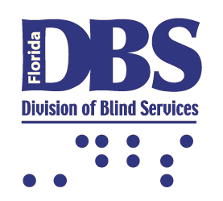
In partnership with others, create a barrier-free environment in the lives of Floridians with visual disabilities.

DBS Vision Statement

- Governor Rick Scott announced six appointments and two reappointments on January 4, 2019.

Accomplishments
- The FRCB maintained its mission and focus on strategic planning that is closely aligned with the priorities of the Florida Division of Blind Services.
- The Council continued to review policy and provide advice on the implementation of best practices. During 2019, the Council reviewed Policy’s; 2.09 Post-Secondary Education, 2.35 Competitive Integrated Employment, 2.5 Informal/Formal Review Process and Mediation.
- The FRCB elected a new Chairperson, First Vice-Chairperson and Second Vice-Chairperson at the first quarterly meeting held in February 2019 in Daytona Beach.
- The FRCB elected new members to serve on the Evaluation and Planning Committees.
- The FRCB continued to strengthen its working relationship with other councils within the state as required under Sec 105 of the Rehab Act. The FRCB and the FRC collaborated together during Committee Week in January 2019 in Tallahassee. The FRCB provided handouts to Legislators to inform representatives and increase awareness of the services provided by the Division of Blind Services.
- The FRCB continued to serve as an effective vehicle for cultivating meaningful partnerships between the FDBS and other stakeholders.
- The FRCB paid increased attention to FDBS’s performance goals and objectives.
- The FRCB held four quarterly meetings in Miami, Daytona Beach, Tallahassee, and Ocala.
- The FRCB conducted four public forums at each of its quarterly business meetings.
- The FDBS and the FRCB facilitated the participation of council members in the NCSRC Spring Training Conference, April 2019 and the Fall Training Conference, October 2019. A total of seven members including 5 new members attended the fall conference in Jacksonville.
- The Council continued to oversee the development and implementation of the Client Satisfaction Survey (CSS). The FRCB contracts with Florida State University Survey Foundry to conduct the CSS. The SFY 2018/2019 Annual Report can be found on the FDBS website by following the link: Florida Division of Blind Services Website.
- The FRCB made suggestions for the Comprehensive Statewide Needs Assessment which was facilitated by San Diego State University.
- The Council drafted a letter regarding their position on Competitive Integrated Employment. The letter was mailed to all Florida Representatives in the US House of Representative, Florida Senator’s Marco Rubio and Rick Scott and RSA.
- The FRCB received regular updates on an initiative being sponsored by the Blind Services Foundation to develop a vocational evaluation tool.
- The FRCB presented a plaque of appreciation for employing individuals with visual disabilities to an employer at each quarterly meeting. The following employers were recognized for 2019: Disability Solutions & Merry Maids, Daytona Beach Meeting – February 2019; Sodexo, Tallahassee Meeting – May 2019; Taxes Untangled, Ocala Meeting – July 2019.

Strategic Plan Goals
Goal 1: Highest Client Achievement
Objective: Coordinate and secure high-quality training, education, work experiences and partnerships that create opportunities for blind and visually impaired Floridians to obtain and maintain independence, post-secondary education credentials, and successful employment outcomes.

Goal 2: Seamless Articulation and Maximum Access

Objective: Create a comprehensive service delivery system that fosters accessibility and provides positive experiences for blind and visually impaired Floridians enabling them to matriculate from school/training to work. Improve outreach methods to reach more consumers, advocates, providers, employers, and other stakeholders.

Goal 3: Skilled Workforce and Economic Development

Objective: Assist blind and visually impaired Floridians with obtaining, maintaining and advancing in competitive integrated employment.

Goal 4: Quality Efficient Services

Objective: Create an accountable and exemplary division workforce that ensures high-quality services.

DBS District Offices
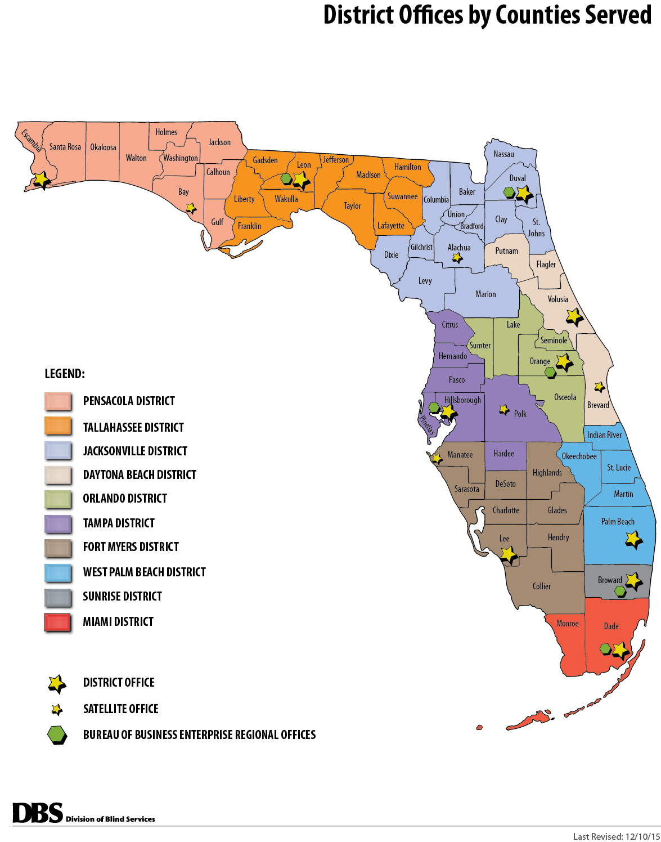

During the 2018-2019 FFY, the FRCB held four meetings: Miami, Daytona Beach, Tallahassee and Ocala At each quarterly meeting, a public forum was held to receive consumer input on the effectiveness of services provided by DBS.

Quarterly Meetings and Public Forums

Agenda Items

- Welcome, Introductions and Pledge of Allegiance
- Adoption of Agenda
- Director’s Report: Division of Blind Services Updates
- District Administrator’s Report
- Employer Recognition
- Local Community Rehabilitation Program Reports
- Client Satisfaction Survey Data Updates
- Division of Blind Services State Plan Updates
- Vocational Rehabilitation Employment Outcome Updates
- New Committee Appointments
- Bureau of Business Enterprise Update
- FDBS Budget Report and Legislative Updates
- Blind Services Foundation Update
- Updates on Outreach to Underserved/Unserved
- Strategic Plan Discussions
- Policy Review: 2.09, 2.35, 2.5

2018-2019 Meeting Dates and Locations

October 17-19, 2018 - Miami
February 5-6, 2019 – Daytona Beach
May 9-10, 2019 – Tallahassee
July 25-26, 2019 – Ocala

The Florida Rehabilitation Council for the Blind and the Division of Blind Services annually offers their gratitude to local businesses and employers who support FDBS by hiring and showing support towards individuals who are blind or visually impaired by creating a barrier-free environment allowing them to obtain their independence.

Employer Recognition

The FRCB and FDBS presented the Appreciation Awards at each quarterly business meeting. For FFY 2018-2019, the following employers were recognized:

Disability Solutions & Merry Maids

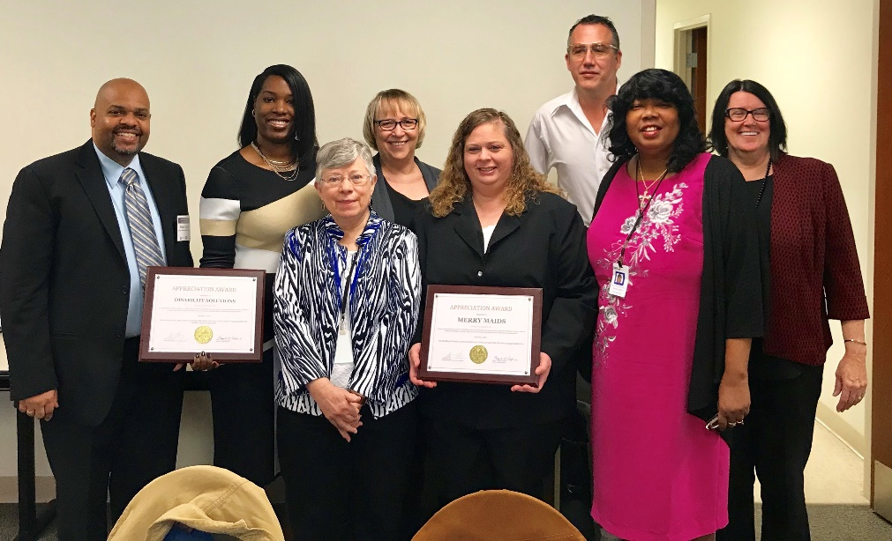

Sodexo

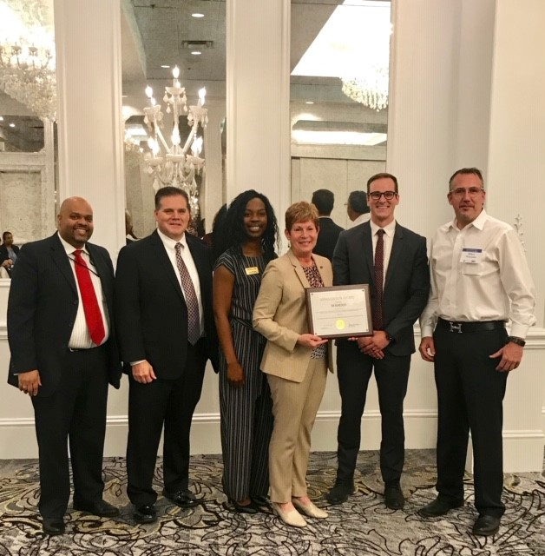

Taxes Untangled

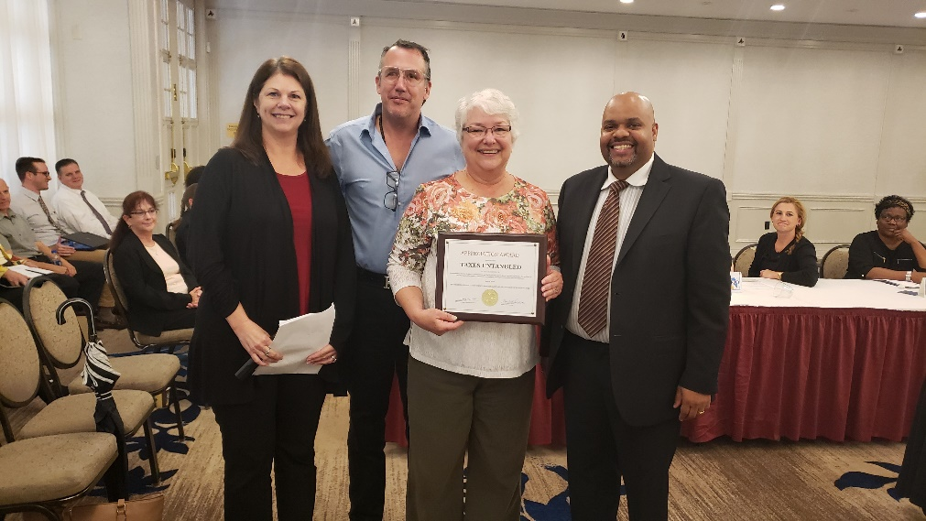

Challenge Enterprises

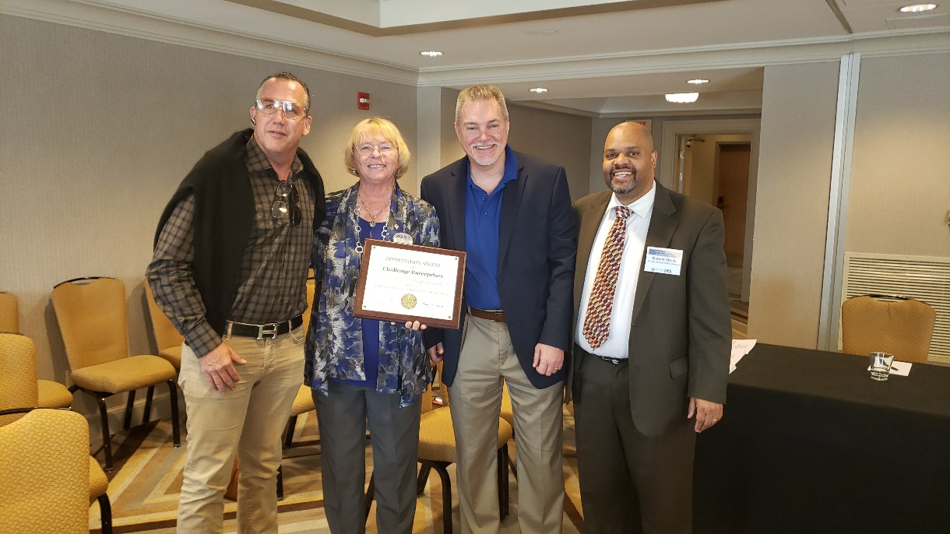

Expenses
Expense | Oct-18 | Nov-18 | Dec-18 | Jan-19 | Feb-19 | Mar-19 | Apr-19 | May-19 | Jun-19 | Jul-19 | Aug-19 | Sep-19 | Total
Council Travel | 2,242.61 |  |  | 810.88 | 5,734.72 |  | 1,190.55 | 4,594.93 |  | 6,595.24 |  |  | $ 21,168.93
Client Satisfaction Survey | 13,500 |  |  |  |  |  |  |  |  |  |  | 13,500 | $ 27,000
Advertising | 76.72 | 0.00 | 26.32 | 0.00 | 56.70 | 0.00 | 26.88 | 60.06 | 0.00 | 25.34 | 0.00 | 0.00 | $ 272.02
Venue Meeting Space | 1,342.00 |  |  |  | 0.00 |  |  | 2,074.00 |  | 1,994.49 |  |  | $ 5,410.49
Supplies |  |  |  |  |  | 63.30 |  |  |  | 108.00 |  |  | $ 171.30
Interpreters |  |  |  |  | 1,755.00 |  |  | 2,875.00 |  | 1,800.00 |  |  | $ 6,430.00
Total | 17,161.33 | 0.00 | 26.32 | 810.88 | 7,546.42 | 63.30 | 1,217.43 | 5,518.93 | 0.00 | 10,523.07 | 0.00 | 13,500 | $56,304.38

Beginning in 2004, the Florida Rehabilitation Council for the Blind decided to collect customer satisfaction data on a more “real-time” basis. Rather than conduct one survey that included all of the clients who had their cases closed the preceding year, the Council decided to have the data collected on a monthly basis and review the results at their quarterly meetings. This report summarizes the data collected for the 2017-18 state fiscal year, which includes cases closed between July 1, 2017 and June 30, 2018. The Customer Satisfaction Survey of former Division of Blind Services (DBS) clients gathers perspectives of former DBS clients concerning program services, levels of satisfaction, and areas for program improvement. This report describes the methods used and presents the 2017-2018 results for clients with cases closed between July 1, 2017 and June 30, 2018. In the fall of 2009, the Florida Rehabilitation Council for the Blind modified the previous survey to streamline the interviews and update information in new areas. Some minor modifications to this survey were made in October 2010. Many of the items remained comparable or identical to the survey administered the previous 7 years. In these instances, data for the 10 previous years are provided for comparison purposes. For new questions, major modifications made to question wording, or questions asked of different populations (new screens), no comparisons to prior years can be made. In 2015, the fiscal year changed from the months of April through March to the months of July through June. Data for the years of 2014, 2015, 2016 and the current year are based on the new schedule.

Customer Satisfaction Survey (2018-2019)
Beginning in July of 2017, the Florida Rehabilitation Council for the Blind has included questions regarding local service providers in addition to DBS.

Survey Procedures
The Florida State University Survey Foundry (FSUSF), Institute of Science and Public Affairs, conducted a telephone survey of former Division of Blind Services (DBS) clients on a monthly basis. The population for the survey was comprised of employment-bound clients with cases “closed” between July 1, 2017 and June 30, 2018.

DBS provided the names, addresses, phone numbers and demographic information for 881 former clients. Among them, one client that did not have a phone number on record. Case closures are classified into two major groupings, those with successful and unsuccessful closures. Among the successful closure group, we include clients whose case status are post closure.

Overall Satisfaction

Client Satisfaction with the DBS program is high.

To gauge the overall level of satisfaction with the DBS program, former clients were asked if they would recommend DBS services to others. During 2017-18, 94 percent (181 of 201), said, “Yes”, they would recommend DBS services to others. Clients were also asked to rate their overall satisfaction with the program. During 2017-18, 84 percent of the clients (165 of 196) were either “Satisfied” or “Very Satisfied with the program.

Beginning in 2017, former clients were also asked to evaluate their local service providers separately from DBS. During 2017-2018, 92% would recommend their local service provider. When clients were asked to rate their overall satisfaction with their local service provider, 94% were satisfied.

For a complete copy of the Customer Satisfaction Survey of Division of Blind Services Clients survey results for SFY 2018-2019, please visit our website at the link below.

Florida Division of Blind Services Website

Florida DBS VR Performance-Based Budget Measures

Outcomes

DBS VR Performance Based Data | FFY2014 | FFY2015 | FFY2016 | FFY 2017 | FFY2018 | FFY2019
Number of Customers Served | 5357 | 5282 | 5333 | 5039 | 5031 | 4997
Number of Customers Successfully Closed | 721 | 771 | 813 | 851 | 856 | 878

Consumers Earnings Data –Federal Fiscal Year

 | FFY2014 | FFY2015 | FFY2016 | FFY 2017 | FFY2018 | FFY2019
Average # of Hours worked per week | 29.64 | 28.98 | 27.76 | 28.94 | 29.96 | 30.24
Average Hourly Wage | 13.54 | 13.96 | 12.98 | 13.85 | 14.61 | $14.69
Average Weekly Wage | $399.85 | $403.56 | $384.61 | $405.21 | $441.62 | $456.62
Projected Average Annual Earnings at Placement | $20,792.15 | $20,984.93 | $19,999.86 | $21,070.72 | $22,964.30 | $23,744.17
Average Case Cost | $6,931.53 | $7,982.29 | $8,288.05 | $9,625.00, | $9,215.26 | $9770.24

DBS Cases Achieving Employment

Committees

Executive Committee

Mikey Wiseman, Chair
Dwight Sayer, First Vice Chair
Denise Valkema, Second Vice Chair

Planning Committee

Paul Edwards, Chair
Howard Bell
Robert Kelly
Kim Carr
Paul Kurtz
Denise Valkema
Jorge Hernandez
Tracie Inman

Evaluation Committee

Bruce Miles, Chair
Patricia Lipovsky
Howard Bell
Tracie Inman
Robert Kelly
Dwight Sayer
Nicole Attong
Louise Peyton

How to become a FRCB Member
The governor appoints the members of the council in accordance with Section 105 of the Rehab Act and Chapter 413.011, Florida Statutes. Appointments are for three-year terms. A majority of the council shall be persons who are: (1) blind, and (2) not employed by the division.

The Gubernatorial Appointments Questionnaire can be found at Governor's Appointment Website
Questions regarding the Council or the application process may be directed to:
Florida Rehabilitation Council f/t Blind
Florida Division of Blind Services
325 West Gaines Street
Tallahassee, Florida 32399
Telephone :( 850) 245-0329
Fax: (850) 245-0363
Office of Governor Ron DeSantis
Appointments Office
Telephone (850) 717-9243
Fax: (850) 921-0733

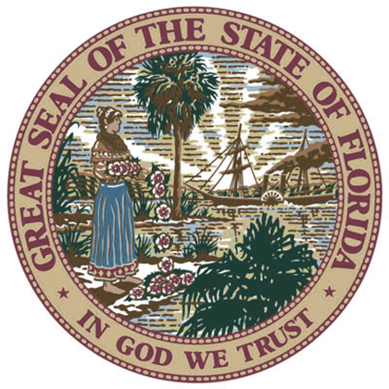
For More Information, Please Contact:
Selena Sicker
Staff Assistant, Florida Rehabilitation for the Blind
Division of Blind Services
325 West Gaines Street
Tallahassee, Florida 32399
Selena.Sickler@dbs.fldoe.org
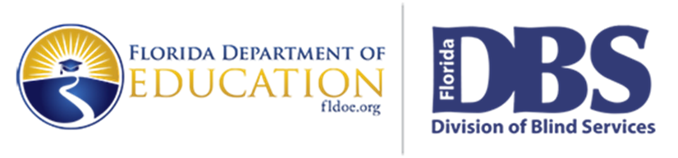
www.dbs.myflorida.dbs.fldoe.org

